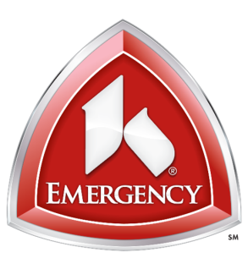
Sycamore Medical Center

Dear Valued EMS Providers,

Kettering Health Network continually strives to provide the best facilities and experiences for our EMS and Health Care Providers. Sycamore Hospital EMS Lounge will be undergoing renovation during the week of March 25, 2019. The projected completion date is Friday March 29, 2019.

We sincerely appreciate your understanding while we make these improvements, and we apologize for any inconvenience this may cause.

Should you have any questions or concerns, please do not hesitate to contact me.

Sincerely,

John Hildebrand
EMS Coordinator
(937) 298-3399 Ext. 45773
John.Hildebrand@ketteringhealth.org

