Mental Health training
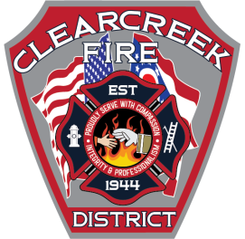

When: August 23rd, 2019 @ 0900 - 1200.
Where: CCFD Station 21 – 925 S. Main St. Springboro, Ohio
What: First responders deal with stresses and traumatic events on a regular basis. But who do they turn to when they start having trouble dealing with those stresses and traumatic events.
Join us as Battalion Chief Steve Conn from Colerain fire and FF/PM Jason Callihan from Hamilton fire share their personal stories and how they overcame the effects of PTSD and are now helping others. Carla Urbanas, Counselor, MS, LPCC-S, LICDC with Professional Counseling Services of Ohio will also be here to talk about the benefits of Peer Support Teams, EMDR, and other resources available to those who need it.
You will learn how to recognize PTSD, the resources available to first responders and the positive effects that a Peer Support Team can have for any organization.
Seating is limited to 50. CEU hours will be awarded at the end.
