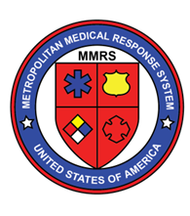  annual dayton mmrs/rmrs steering committee meeting  November 12th, 2019  8:00AM – 3:30PM  Breakfast at 7:30 AM  Lunch with our speakers also included  Bieser Auditorium in the Berry Women’s Center, Miami Valley Hospital  One Wyoming Street, Dayton, OH 45409  Who Should Attend?  -Law Enforcement -Hospitals  -EMS -Fire Departments  -Public Safety Dispatchers -EMAs  -Coroners -Public Health  Why? GREAT Presentations including:  - Jon Krohmer, MD, Director of the federal Office of EMS on “Paradigms and Pitfalls of Mass Casualty Trauma Triage – Real World issues”  - HHS ASPR HPP on Pandemic Preparedness  - DHS Intelligence Report  - FBI WMD Report  - Poisoning Death Review & Overdose Response Efforts  - Preparedness Case Studies: HSK Rally & Gem City Shine  - Dayton Oregon District Active Shooter Incident  - Upcoming Exercise Plans for West Central Ohio  - Our Region’s Reports from MMRS/RMRS, Public Health, & Hospitals and MUCH MORE! | Continuing Education, food, and venue courtesy of:  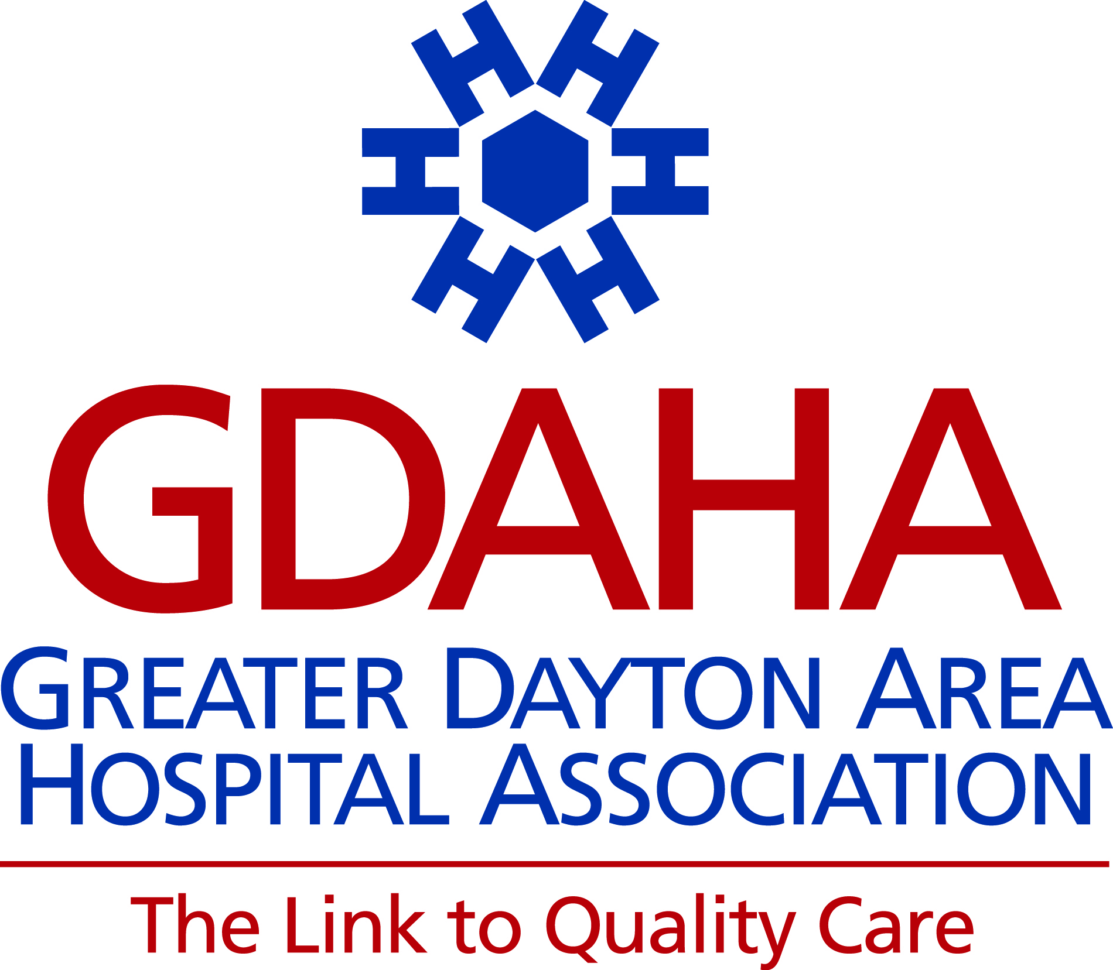  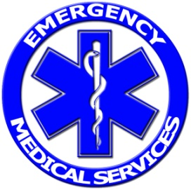  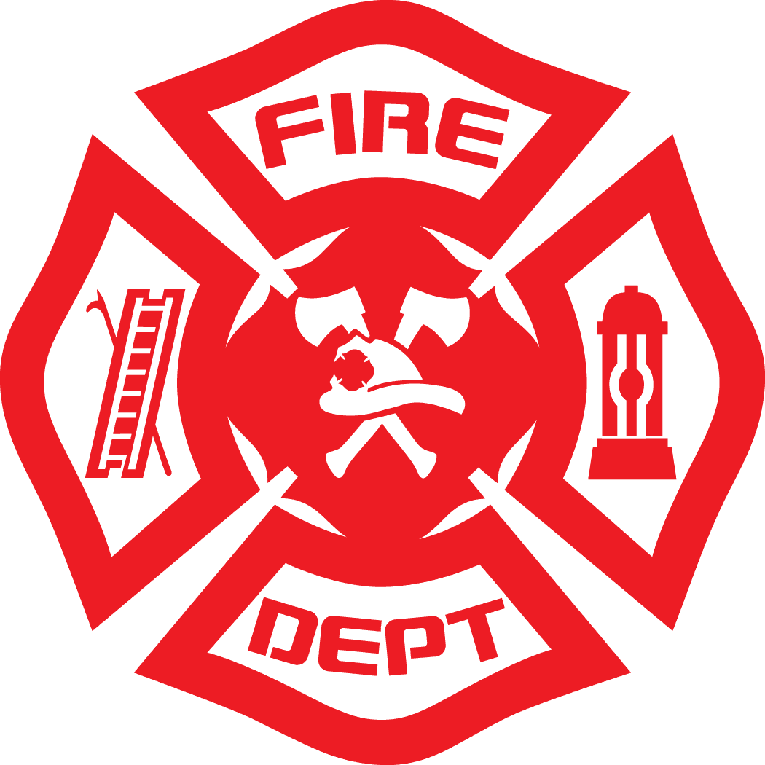  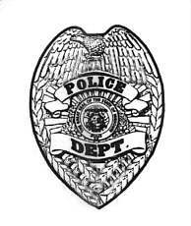  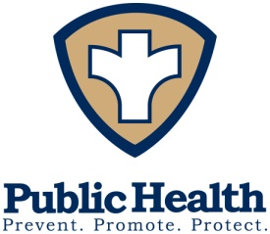  Seating is limited! REGISTER NOW  www.surveymonkey.com/r/MMRSSteering2019

