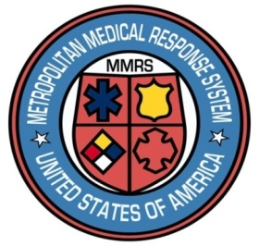

**Dayton MMRS Public Health - GMVEMSC**

**Dayton & Montgomery County**

**Wuhan Coronavirus Update and Recommendations**

This provides information regarding the 2019 novel coronavirus (2019-nCoV), first identified in Wuhan, China. This was developed with input from Public Health – Dayton & Montgomery County and the Region 3 Regional Physicians Advisory Board. Patients with the virus have been identified in China, Thailand, Japan, and the state of Washington. Below are recommendations on how EMS and fire agencies may choose to manage the current situation. It is the responsibility of each agency’s chief and medical director to determine the procedures for that agency. This is drawn from CDC materials and recommendations from local/regional groups.

There are concerns about this disease, but EMS deals frequently with infectious diseases. Precautions we use at other times will offer protection from this coronavirus as well. CDC is closely monitoring this outbreak, and a CDC Health Update is attached. Over 300 cases have now been confirmed, with multiple deaths.

Per CDC, limited information is available regarding this illness. No vaccine or specific treatment for 2019-nCoV infection is available. Care is supportive.

CDC recommends obtaining a travel history for patients with fever and acute respiratory illness. At this time we are not recommending that Dispatch Centers/PSAPs screen callers for travel history. EMS personnel during on-scene assessment, should consider asking patients with lower respiratory illness about travel history with short, simple, open-ended questions: have you traveled outside the U.S. in the last three weeks and, if so, where?

If any patients meet both of the following criteria, the ED should be notified prior to arrival:

* Fever or symptoms of lower respiratory illness (e.g., cough, shortness of breath),
* In the last 14 days before symptom onset, a history of travel from Wuhan, China or close contact with a person who is under investigation for 2019-nCOV while that person was ill.

Patients under investigation for 2019-nCoV should be asked to wear a surgical mask. Use oxygen by nasal cannula under the mask if needed.

* EMS should use standard, contact, and airborne precautions, and eye protection.
* EMS personnel should wear: **Gown or Coveralls, Mask or Respirator, Goggles/Face Shield, and Gloves. Perform hand hygiene after patient care.**

After arrival at the ED, notify the healthcare facility’s infection control personnel following the Greater Dayton Hospital Association & Greater Miami Valley EMS Council Infectious Disease Exposure Reporting Policy.