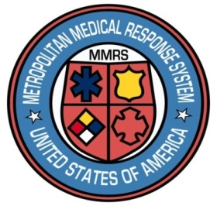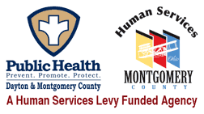

**Dayton MMRS Public Health - GMVEMSC**

**Dayton & Montgomery County**

**COVID-19 Bulletin 10:**

**EMS Patient Transport Concerns and Refusals Considering COVID-19**

Hospital officials both locally and nationally are urging people who have avoided medical treatment during the COVID-19 pandemic to seek care when needed. EMS needs to do the same.

An unexpected consequence of COVID-19 has been that some patients have been afraid to get medical care. National studies have found that people with issues as serious as strokes, myocardial infarctions, and fractures have delayed going to hospitals, in some cases for days or longer.

Locally, EMS crews have had patients refuse transport. For many agencies, EMS run volume declined, partly due to fear that going to a hospital to be treated for a gall stone attack could mean leaving the hospital infected with COVID-19.

We must all encourage people to seek care when they need it. No one knows better than EMS about time critical diagnoses, and EMS can have a huge impact on this problem.

* Encourage every patient needing care to allow you to transport them to the appropriate hospital.
* Reassure your patient that our hospitals are safe spaces.
* Our hospitals have taken extensive steps to keep things safe for patients, employees, and visitors.
* Hospital personnel are required (not encouraged) to wear all appropriate personal protective equipment (PPE) to protect themselves from any possible infection with COVID-19, and to prevent spread from patient to patient.
* Our hospitals are open, and exceptionally safe places to receive care.