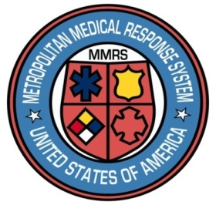

**Dayton MMRS Public Health - GMVEMSC**

**Dayton & Montgomery County**

**COVID-19 Bulletin 11:**

**Caution Fatigue During COVID-19**

Is it still worth it? Do we still need to…?

Everyone is tired of the many ways COVID-19 has changed our society. Tired of wearing masks, not shaking hands or hugging, having our temperature checked daily at work, being asked the same screening questions before entering work, and a thousand other things.

Psychologists call it caution fatigue, and it’s especially hard not to fall victim to caution fatigue when there’s no easy way to see the risks, or to tell if our efforts actually make a difference in keeping us safe. Is it still worth it? Do we still need these precautions?

Is employee screening still worth it? Does it even work? What about those who can spread COVID without having symptoms?

Screening for symptoms allows us to appropriately separate symptomatic individuals, evaluate them, and isolate them from others. This, along with proper hygiene, following of social distancing guidelines, can significantly reduce disease transmission. It helps all of us reduce the risk from this disease. It protects us, our families, and others.

Do we still need to wear masks all the time?

Yes. Wearing masks protect the person wearing the mask, and people nearby. **COVID-19 is still widespread.** It’s not obvious, and you don’t know for certain who may be able to spread the disease – even you.

Wear your mask – it helps protect you and your fellow community members.