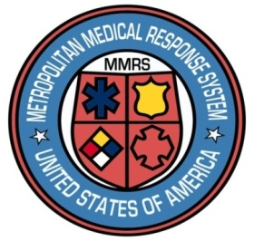 A black sign with white text

Description generated with very high confidence 

**Dayton MMRS Public Health - GMVEMSC**

**Dayton & Montgomery County**

**COVID-19 Bulletin 12:**

**Intranasal Naloxone (Narcan)**

**and Other Medications During the COVID-19 Pandemic**

EMS, law enforcement, other health professionals, and even the general public administer intranasal (IN) medications. In particular, using intranasal naloxone (Narcan™) with a Mucosal Atomization Devices (MAD) or Naloxone Nasal Spray has saved thousands of lives.

Concerns have been raised as to whether IN medication administration is what’s called an aerosol-generating procedure. Aerosols, when inhaled, may infect people nearby with COVID-19.

There is little data on how great the risk of IN medications during the COVID pandemic might be. Some experts feel the greatest concern is when the patient sneezes after the IN drug administration.

We do know IN medications can be lifesaving. Withholding naloxone is equivalent to withholding CPR. There are simple steps to protect yourself and others when using the technique:

* When administering IN medications, wear a mask (preferably a fit-tested N-95 mask), gloves, and if available a gown or coveralls to protect your clothes.
* Place a mask on the patient while preparing to administer the drug. If available, use a surgical (also called an isolation) mask.
* Have others stay at least six feet away unless there is a direct need for them to be in closer proximity. Others should also be in proper PPE.
* Administer the IN medication under the patient’s mask if possible. If not, place the mask back on the patient as soon as administration is complete.
* Perform hygiene (e.g., handwashing) after the procedure.
* Wear your mask – it protects you and others.

It is critical that naloxone continue to be administered when needed, and in a manner that reduces risk of COVID-19 transmission.