**2020 International Overdose Awareness Day**

**Social Media Messaging**

**Hashtags**

#OverdoseAware

#EndOverdose

#NoMoreStigma

#IOAD2020

* On August 31 at Noon please take a moment of silence to recognize pain caused by overdose to those who have lost their lives and to their loved ones.  
    
  <https://www.overdoseday.com/wp-content/uploads/IOAD-Face_Meme-11.jpg>
* Please hold a moment of silence this August 31 at Noon to recognize those who have lost their lives and have been permanently injured as a result of drug overdose.  
    
  <https://www.overdoseday.com/wp-content/uploads/IOAD-Face_Meme-2.jpg>
* On August 31 at Noon please take a moment of silence to recognize the lives affected by overdose. However, this is the only time we should be quiet about overdose. Preventing future deaths requires the courage to speak up.  
  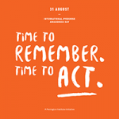  
  <https://www.overdoseday.com/wp-content/uploads/IOAD-Graphic_Memes-11.jpg>
* Preventing overdoses can start right at home. Properly disposing of unused or expired prescriptions can keep your loved ones safe.  
  Video **Keep Your Family Safe From Unused Opioid Pain Medicines (0:60)** | **FDA** | <https://www.youtube.com/watch?v=mh6dyPHWAMA>  
  <https://www.fda.gov/drugs/ensuring-safe-use-medicine/safe-opioid-disposal-remove-risk-outreach-toolkit>

* Thousands of people die each year from drug overdose. They come from all walks of life. They are all someone's someone.  
    
  <https://www.overdoseday.com/wp-content/uploads/IOAD-Face_Meme-6.jpg>  
  

<https://www.overdoseday.com/wp-content/uploads/IOAD-Face_Meme-7.jpg>  
  
<https://www.overdoseday.com/wp-content/uploads/IOAD-Face_Meme-9.jpg>  
  
<https://www.overdoseday.com/wp-content/uploads/IOAD-Face_Meme-4.jpg>

* Age, sex, gender, race, income, or education level, overdose does not discriminate.   
  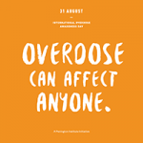  
  <https://www.overdoseday.com/wp-content/uploads/IOAD-Graphic_Memes-13.jpg>  
  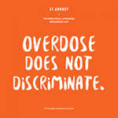  
  <https://www.overdoseday.com/wp-content/uploads/IOAD-Graphic_Memes-3.jpg>
* No more stigma, no more shame. Overdose is preventable, and stopping it requires the courage to confront it.  
  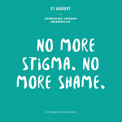

<https://www.overdoseday.com/wp-content/uploads/IOAD_Memes_Graphics_New-13.jpg>

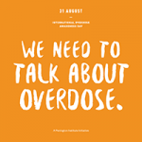

<https://www.overdoseday.com/wp-content/uploads/IOAD-Graphic_Memes-5.jpg>  
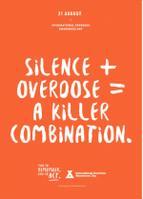  
<https://www.overdoseday.com/wp-content/uploads/IOAD-Graphic_Posters_A3_New-7.pdf>

* Blue lips, chest pain, difficulty breathing? Get help now! Knowing the signs of drug overdose can help save lives.  
  Video **Signs of a Drug Overdose and What To Do If The Situation Occurs |** Banyan Treatment Centers | <https://www.youtube.com/watch?v=wrHKkJvuI94>
* Learn more about International Overdose Awareness Day and read heart-touching tributes shared by people who have lost their someone to drug overdose.

[www.overdoseday.com](http://www.overdoseday.com).  
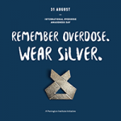

<https://www.overdoseday.com/wp-content/uploads/IOAD-Graphic_Memes-10.jpg>

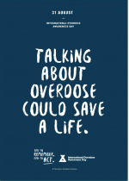  
<https://www.overdoseday.com/wp-content/uploads/IOAD-Graphic_Posters_A3_New-4.pdf>

* International Overdose Awareness Day is held on August 31 each year with these key goals:
  + Raise awareness of overdose
  + Reduce stigma around drug-related deaths
  + Acknowledge the grief felt by families and friends
  + Spread the message that overdose death and injury is preventable  
      
    <https://www.overdoseday.com/wp-content/uploads/IOAD-Graphic_Memes-11.jpg>  
    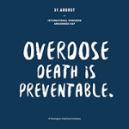  
    <https://www.overdoseday.com/wp-content/uploads/IOAD-Graphic_Memes-14.jpg>

* Naloxone (also called narcan) saves lives. However, overdose can still cause major harm. In addition to acknowledging lives lost, International Overdose Awareness Day highlights the pain of those who have been permanently injured by drug overdose.   
  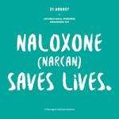  
  <https://www.overdoseday.com/wp-content/uploads/IOAD-Graphic_Memes-4.jpg>

* Accidental overdose deaths have been increasing during the COVID-19 pandemic. Recovery resources are available in Montgomery County. Call Samaritan CrisisCare 24/7 at (937) 224-4646, download the GetHelpNow app at gethelpnowmc.com, or visit mccoat.org/resources for help.  
  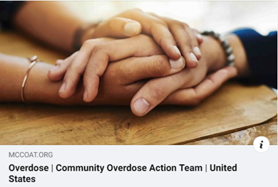[Facebook Link Preview]  
  <https://www.mccoat.org/>

* Loss of jobs and in-person support structures due to the COVID-19 pandemic have led to an increase in overdose deaths throughout Montgomery County. Call Samaritan CrisisCare 24/7 at (937) 224-4646, download the GetHelpNow app at gethelpnowmc.com, or visit mccoat.org/resources for help.  
  [Facebook Link Preview]  
  <https://www.mccoat.org/>

* The FOA Rally 4 Recovery will be held virtually on August 30. Unite with our community to raise awareness, eliminate stigma, and show that recovery works.  
  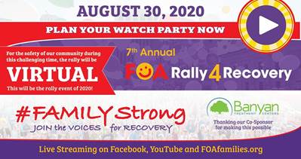[Facebook Link Preview]  
  [www.facebook.com/events/698504840940827](http://www.facebook.com/events/698504840940827)