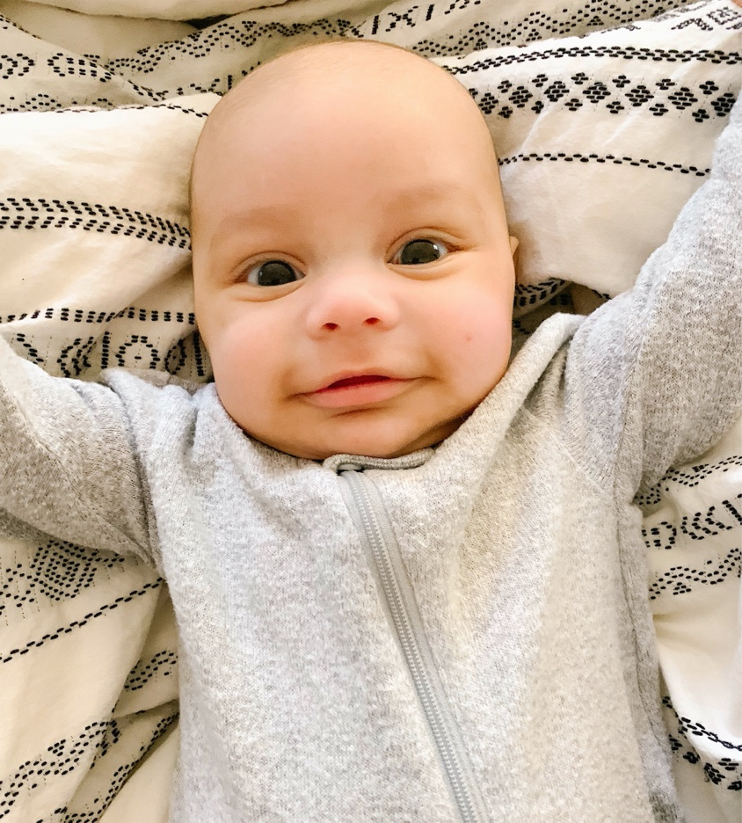

Our Babies Life-Threatening Disease:
This is our son, Noah. At just six weeks old, he was diagnosed with Wiskott–Aldrich Syndrome (WAS), an extremely rare and life-threating genetic disease that affects one in a million males worldwide. His disease makes him immunodeficient, extremely prone to infections and bleeding. Although prognosis varies, it is possible that mortality, if not treated, has a mean death rate of eight years old.

To give Noah a second chance at life, his treatment plan includes a bone marrow transplant. Noah will be one of the youngest WAS patients to receive marrow in North America. Unfortunately, a perfect match has not been identified in our family or through the bone marrow registry at Be the Match. The survival rate of WAS is over 90% with early identification and intervention. Thus, the importance to find his perfect match for this life- saving treatment. Our doctors have been active in Noah’s care and would like to transplant around six months, so we are rushing to find his match!

How You Can Help Save Noah’s Life:
With November being Marrow Awareness Month, the timing seemed right to share Noah’s story and give awareness to the magic of marrow. We are asking for people to get tested as Noah’s possible donor match. We need as many volunteers to click Noah’s specific Be the Match link to request a mouth swab kit and enter the national registry http://join.bethematch.org/NOAHBoutMarrow (the link will not show up as specific for Noah in your browser). Once you enter the registry, you are agreeing to be matched with anyone searching for marrow. Be the Match is looking for individuals between the ages of 18-44 because younger donors provide the best outcome for recipients.

Our son is a spirited, giggling, resilient warrior who has battled through unfavorable circumstances. Noah’s beautifully blended ethnic background makes it more difficult for him to find a match. The chances of finding a perfect match for minorities or mixed ethnicities can be less than 10%. This is where we need you! Regardless of your background, you could be Noah’s match and help save his life or one of the other 7,000+ people actively searching for matches. Please consider being a hero to our hero!

Thank You
We give all our gratitude to God for giving us faith that our boy is going to overcome this. A special thank you to our incredible team of doctors at Nationwide Children’s Hospital for their wisdom and incredible care. Additionally, without our family and friends this journey would seem impossible. Thank you for the unconditional love, prayers and support. Finally, THANK YOU for helping us find a match for our sweet son. He is one in a million!

Click here for more information on the bone marrow

