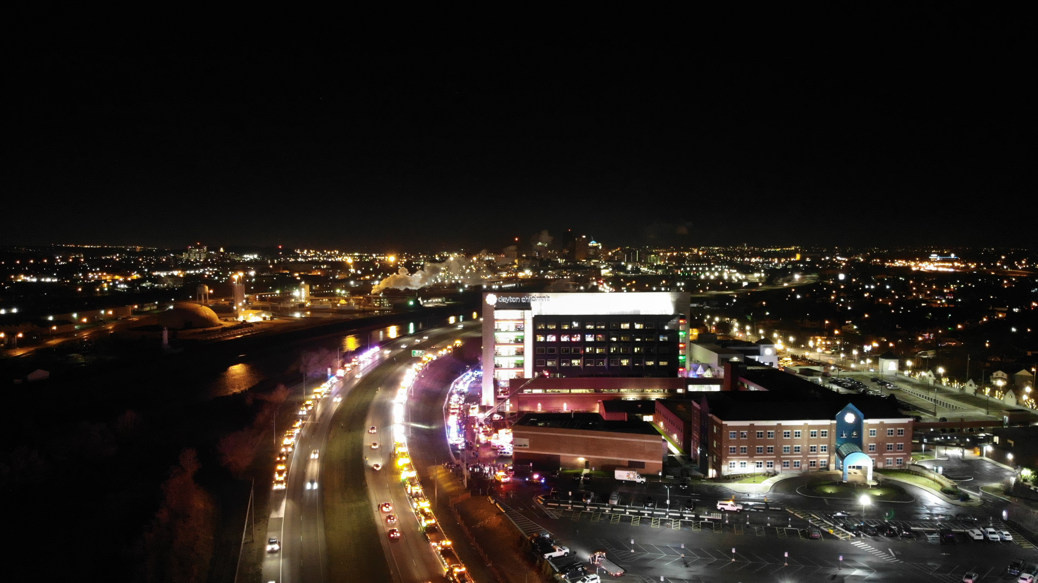

Dayton Children’s Hospital and its Public Safety Department would like to invite all first responders to attend a special Thanksgiving “Good Night Lights”, on Thursday November 26, 2020 at 1 Children’s Plaza, Dayton, Ohio 45404. Upon arrival our officers will direct first responders to the rear of the Tower. *We ask that all responders remain in their vehicles due to the pandemic and the Governor’s orders*. Dayton Children’s Hospital and Public Safety would like to be able to continue with the tradition, once the Miami Valley region is more stable with the numbers of cases going down. We ask that all first responders follow the guidelines, so If you would like to participate please contact Chief/Director Aundray Toney of Dayton Children’s Public Safety at 937-641-4217 or email Toneya@childrensdayton.org. Please make this a special night for the children and families that may be separated due to the COVID pandemic on the holidays. Let’s give the families and children a very special good night. Event will start at 730pm and end at 8pm. Dayton Children’s and families thank you for participating and we look forwarding to seeing you all there.

Aundray Toney
Director/Chief
Dayton Children’s Hospital department of Public safety
Dayton Children's Hospital
One Children's Plaza
Dayton, Ohio 45404-1815
O: 937-641-4217
M: 937-344-6907
E: Toneya@childrensdayton.org

