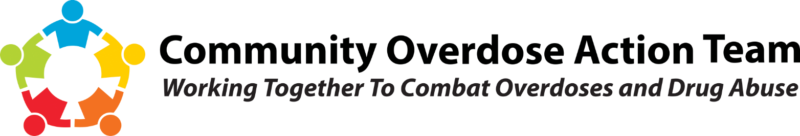
For Immediate Release, 5/19/2021 Contact: Brooke Ehlers
(937) 225-6176
THC-Infused Edibles Warning
The Montgomery County Coroner’s Office and Community Overdose Action Team (COAT) are warning the public of THC-infused edibles being packaged to resemble common snacks found at places such as gas stations and convenience stores. THC is the psychoactive compound of cannabis.
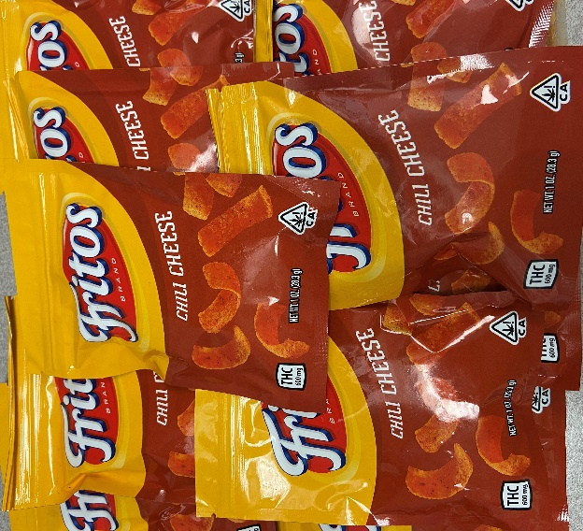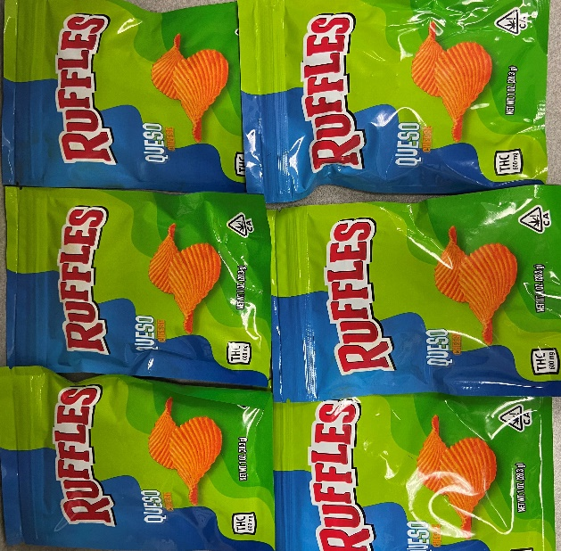
Pictured above: THC-infused edibles confiscated by Dayton Police Department as part of an investigation.

In the state of Ohio, dispensaries are prohibited from selling products with cartoon characters or those bearing a resemblance to commercially available products. However, online sites sell this packaging for use with homemade edibles.
“The THC-infused edibles are often marketed to youth. This is concerning because youth may have trouble discerning the difference between THC-infused edibles and actual food – especially children who cannot read but can recognize familiar packaging,” said Montgomery County Coroner Dr. Kent Harshbarger.
The Coroner’s Office and COAT warn that the products packaged to resemble common snacks likely have not undergone state regulatory guidelines for food quality and safety. Ingestion could result in adverse effects including overdose and illness.
- In the event of a suspected overdose, call 911 immediately. Signs of a THC-related overdose include; extreme confusion, difficulty conversing, poor coordination, high levels of anxiety, paranoia, panic attack, fast heart rate, delusions or hallucinations, increased blood pressure, and severe nausea or vomiting.
- Parents and guardians should carefully inspect the packaging of common snack foods. Look for symbols such as “THC” or other mentions of cannabis on packaging.
- Those purchasing THC-infused edibles on the street should recognize that the products they are buying have likely not undergone state regulatory guidelines for food quality and safety.

The Community Overdose Action Team was established to address the drug overdose and addiction crisis in Montgomery County. The goal is to reduce the number of people dying from drug overdoses and drug abuse. Montgomery County Alcohol, Drug Addiction & Mental Health Services, Public Health – Dayton & Montgomery County, and Montgomery County Administration are lead agencies in the effort to combat the epidemic.

Media Contacts:
Montgomery County Coroner’s Office & Miami Valley Regional Crime Lab: Brooke Ehlers (937) 225-6176 / ehlersb@mcohio.org
Public Health – Dayton & Montgomery County: Dan Suffoletto (937) 224-3892 / dsuffoletto@phdmc.org
Prepared by:

