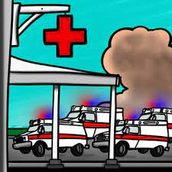

**ARE YOU READY FOR THE *NEXT* MCI?**

**QUARTERLY TRIAGE DAY**

**December 4th 2000 HOURS (8 PM) - December 5th 2000 HOURS (8 PM)**

**Put triage ribbons and tags on each patient for 24 hours!**

**Use ribbon based on condition, severity, and SALT category.**

**FREE CONTINUING EDUCATION!**

**Use the multiple free training materials on MCIs, SALT triage, and MCI communications trainings.**

**REVIEW**

**RIBBONS & TAGS**

**RADIO**

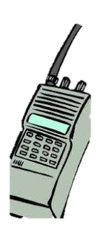

**After participating, fill out this feedback form!**

**GET THE WORD OUT!**

**Post this flyer! Tell all line personnel in EMS and in EDs!**

**QTD drills help our region better prepare for all types of MCIs.**

**THANK YOU FOR PARTICIPATING!**

**Hospitals monitor MCI radios and EMS crew should do MCI style reports over MCI radio talk groups.**

**Between 8PM-12AM on 12/4 and 8AM-12PM on 12/5:**

**Education is found at gmvemsc.org**

