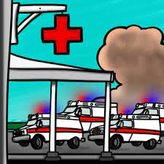

**ARE YOU READY FOR A**

**QUARTERLY TRIAGE DAY?**

**March 6th 2000 HOURS (8 PM) – March 7th 2000 HOURS (8 PM)**

**Put a Triage Ribbon on *every* patient for 24 hours!**

**Use ribbon based on condition, severity, and SALT category.**

**FREE CONTINUING EDUCATION!**

**Use the multiple free training materials on MCIs, SALT triage, and MCI communications trainings.**

**REVIEWS**

**RIBBONS**

**RADIOS**

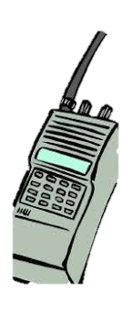

**After participating, fill out this feedback form!**

**GET THE WORD OUT!**

**Post this flyer! Tell all line personnel in EMS and in EDs!**

**QTD drills help our region better prepare for all types of MCIs.**

**THANK YOU FOR PARTICIPATING!**

**Hospitals monitor MCI radios and EMS crew should do MCI style reports over MCI radio talk groups.**

**Between 8PM-12AM on 3/6 and 8AM-12PM on 3/7:**

**Education is found at gmvemsc.org**



