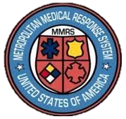

**Metropolitan Medical Response System (MMRS) Intern**

**May 2022 - May 2023**

* **Current postings can be found at:**

[**https://socheintern.org/students/**](https://socheintern.org/students/)

* **The Dayton Fire internship can be found by selecting Dayton Fire Dept. MMRS Intern.**

**How to Apply**

**Scan the Code to Apply Now**

* **Deals with planning and preparedness for multiple major events**
* **Opportunities to work with area hospitals and public health agencies**
* **Interact/learn from experts in EMS, public health, Law Enforcement, Medicine, etc.**
* **Help the region prepare and respond to large-scale incidents, including COVID Pandemic**

**About Internship**

**MMRS Coordinator**

David Gerstner

Phone: 937-333-4551 David.gerstner@daytonohio.gov

**Current Interns**

Jacqueline Tyler & Bill Rose

Phone: 937-333-5148

Jacqueline.tyler@daytonohio.gov

William.rose@daytonohio.gov

**Contact for more Information**

**HIRING**

**NOW**

**Public Safety Metropolitan Medical Response System (MMRS) Intern**