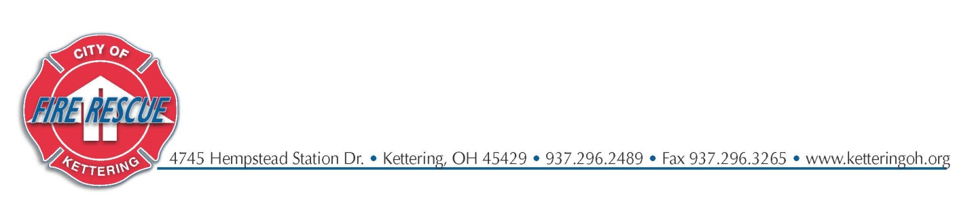
Line-of-Duty Death (Active Duty Level) Notification for
Firefighter/Paramedic Tracy Leach
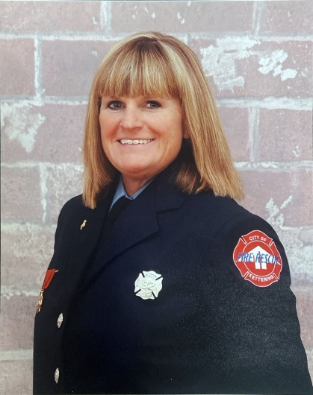
It is with deepest regret and sorrow that the Kettering Fire Department must announce the Line-of-Duty Death (Active Duty Level) of Firefighter/Paramedic Tracy Leach as of the evening of December 24, 2022. Tracy passed away after succumbing to occupational cancer. Tracy served the Kettering Fire Department with distinction with more than 21 years of service.
Tracy's funeral arrangements will be conducted with appropriate honors on January 4, 2023, and those details are:
- Memorial services will be held at Apex Church
5200 Far Hills Ave, Kettering, OH 45429
  - 0850 Arrival of FF/P Tracy Leach (Honor Cordon & Presentation of Arms from uniformed personnel)
  - 0900-1000 Private viewing for family & invited friends
  - 1000-1100 KFD and Bellbrook FD viewing
  - 1100-1245 Public viewing
  - 1300 Memorial services begin
- Graveside services will be at Valley View Memorial Gardens
170 N. Valley Rd., Xenia, OH 45385

To place fire apparatus in the procession to graveside service please contact Assistant Chief Mike Miller at Michael.Miller@ketteringoh.org or via phone at 937.296.2489 or c- 937.367.3284.

To offer assistance with KFD operational staffing coverage please contact Assistant Chief David Roth at David.Roth@ketteringoh.org or via phone at 937.296.2489 or c- 937.901.5822.

For coordination of Fire Department Honor Guards contact Captain Kris Denlinger at Kristopher.Denlinger@ketteringoh.org or via phone at 937.903.2332.

In lieu of flowers, donations may be made to Francis Kennels at: http://www.franciskennels.com/give.

Or by mail to:
Francis Kennels
1984 Lower Bellbrook Rd
Xenia, OH 45385

