Dear Ohio EMS Agencies,

I am the EMSC Program Manager for Ohio.
I want to thank you for your dedication to EMS response during these challenging times. The collection of data to understand the needs of EMS systems has never been more important.

In early 2022 we supported a nationwide survey of EMS agencies to learn more about EMS skills and coordination that are used to care for children. In order track data over time and to help us know how we can best help you to continue to provide high quality care for children, we will conduct the same brief survey in early 2023.

Please consider participating when you receive the invitation by email in January.

Jess Davis, BA, NRP
Ohio EMS for Children Program Manager

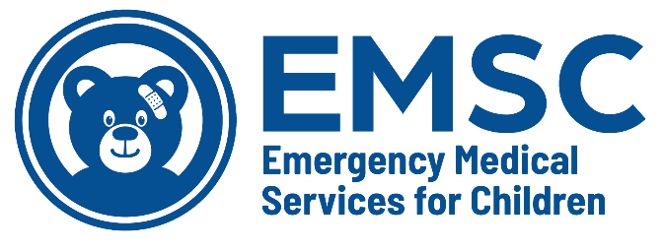
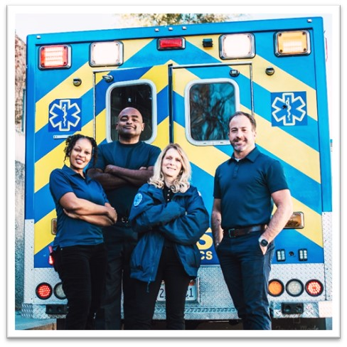
For more information, review the January 2020
Pediatric Readiness in EMS Systems, Policy Statement
Jess Davis, BA, NRP
EMS for Children Project Manager
Nationwide Children’s Hospital
Jessica.Davis2@NationwideChildrens.org
Office: 614.722.4345 | Mobile: 303.358.2105

