August 18, 2023

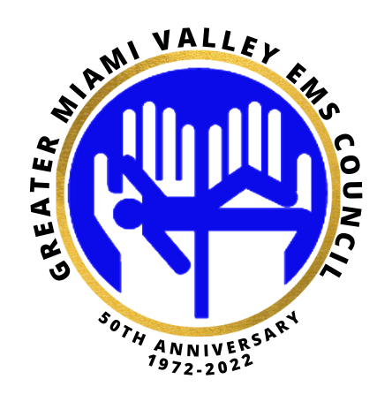

Research and Community Paramedicine Committee Newsletter
Nancy Pook MD FACEP, Chair Research committee
Kendra Harris EMT-P

Topic #1
EMS WELLNESS

We met with Steve Click, from the Office of First Responder Wellness.
He is available to speak on the following subjects, either in person or via Zoom:

Crisis Awareness
After the Call
Self-Care
QPR (Question, Persuade, Refer)
First Responder Suicide Awareness
Prevention Retirement
Being a member of the Survivors’ Club Ohio Office of First Responder Wellness – Resource Overview

We look forward to having Steve at an upcoming meeting. Steve can be reached at STClick@dps.ohio.gov

Topic #2
INVOLUNTARY
COMMITMENT

We participated in meetings with law enforcement,
EMS, and the Montgomery County probate court
regarding the management of pink slips from the
field to the ED to the hospital.

Take-aways:
All patients with a pink slip are taken very
seriously within the hospital system.
This includes careful safety monitoring,
lab evaluation, crisis behavioral health
involvement and pharmaceutical management
when indicated.
Who can complete a pink slip?
Licensed physician
Psychiatrist
Clinical psychologist
Health officer
Law enforcement officer
Sheriff or deputy sheriff

Use of a pink slip is ONLY for a patient with a MENTAL HEALTH disorder, not for medical
conditions or to avoid a refusal of transport.

Topic #3
OneFifteen Announces Transition to Clinical Provider

As a part of this strategic transition, OneFifteen will conclude its partnership with Samaritan Behavioral Health Inc.
After a four-year initial phase of ramping up operations to serve more than 7,000 patients in Montgomery County, OneFifteen is proud to announce that it will become an independent clinical care provider in Dayton, Ohio. As a part of this transition, OneFifteen and Premier Health have mutually agreed not to renew OneFifteen’s operating partnership with Samaritan Behavioral Health Inc., a subsidiary of Premier Health. SBHI will wind down operations at OneFifteen in stages from September through December 2023. OneFifteen will resume services at the same site over the next six months.

“OneFifteen is excited to continue our work in Dayton,” said OneFifteen President and CEO, Marti Taylor. “Based on our innovative learning health model, which uses data to make improvements, we recognize that now is the right time for OneFifteen to enter this next phase to meet the unique needs of those living with addiction in our community and across the U.S.” As a provider, OneFifteen will continue to prioritize accessible, differentiated, and evidence-based services; specifically:

- OneFifteen Living - The 58 bed low-intensity residential unit, which was the first of its kind in Ohio, will remain open and operated in partnership with Recovery Innovations International.
- OneFifteen/SBHI Crisis Stabilization Unit (CSU) - The unit will continue to operate 24/7 until September 22, 2023, at which time the hours will be 7am to 5pm. On December 1, 2023, the CSU will close temporarily. OneFifteen will begin similar operations in 2024.
- OneFifteen/SBHI Inpatient Residential - The inpatient residential services will temporarily close on September 22, 2023, and new patients will no longer be accepted as of August 25, 2023. OneFifteen will begin operations in 2024. During the interim, prospective patients will be referred to other residential providers in the community.
- Outpatient Services - SBHI will continue to operate outpatient services at OneFifteen’s campus until December 31, 2023. In January, SBHI will move its outpatient services to 601 S. Edwin C. Moses Blvd. in Dayton. OneFifteen will begin its own outpatient operations in 2024.
- Recovery and Affordable Housing - OneFifteen will continue to develop recovery and affordable housing options in the Carillon neighborhood, in partnership with the City of Dayton and the Carillon Civic Council.
- Care Coordination - OneFifteen will continue its care coordination services in partnership with the Greater Dayton Area Hospital Association.

Both OneFifteen and SBHI will work to ensure continuity of care for patients during this transition. Patients who have questions about their services can reach out to their SBHI provider at their next appointment or call (937) 535-5115. Those experiencing a mental health crisis should call 988 or the Montgomery County crisis line at (833) 580-2255.

Health provides a comprehensive range of care choices at its seven emergency departments, eight Urgent Care locations, and more than 130 outpatient locations and affiliated primary care and specialty physician offices, as well as home health, behavioral health, and substance abuse services. A subsidiary of
Premier Health, Samaritan Behavioral Health (SBHI) has been serving residents of the Southwest Ohio community for more than 50 years. SBHI is committed to offering a wide range of mental and behavioral health and substance use services that teach, touch, and heal. With an experienced team of psychiatrists, psychiatric nurse practitioners, licensed counselors and social workers, and registered nurses, SBHI offers services from outpatient services to in-home counseling for substance abuse.

Media Contacts

Karen Kelly Brown, OneFifteen
937-941-9257
kkellybrown@onefifteen.org

Ben Sutherly, Premier Health and Samaritan Behavioral Health, Inc.
937-524-3264
bwsutherly@premierhealth.com

Topic #4
Fierce Healthcare Webinar

Webinar: How to Close Care Gaps At Home & In The Community

Thursday, Sep 14, 2023 | 1:00pm ET / 10:00am PT

In recent years, there has been a dramatic shift to improve healthcare accessibility and affordability. At-home diagnostic companies, pharmacies, health plans, and digital & home health platforms have all evolved to bring care closer to their communities and into the home. Each vertical within the healthcare ecosystem is strongly committed to closing care gaps and breaking down social determinants of health.

Register Now

From this panel, you’ll hear actionable insights from leaders across these verticals on:
- Their unique viewpoints on how innovation can drive care into the community setting
- Real-world examples of “TechQuity” - the practice of developing & deploying healthcare technology to achieve health equity
- First-hand successes and challenges with the evolution of the patient care model
- Best practices for building scalable, home-based and community-centric healthcare programs that close gaps in care

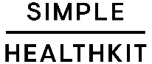
Topic #5
Updates

- Starting the month of September we will send invites through zoom and once accepted it should automatically upload to your calendar.

- Please take a few minutes to watch the new DispatchHealth video. We thought this was very interesting especially since there is one located in the Southwest region.

https://www.dispatchhealth.com/blog/dispatchhealth-perspective-complete-system-of-care-home/

https://www.youtube.com/watch?v=lMuTB_8t6CE

- Next research meeting will be held via zoom on September 19, 2023 from 10am-12pm, please join us.

“To know even one life has breathed easier because you have lived. This is to have succeeded.”—Ralph Waldo Emerson

