Emergency Department Job Aid
For Patients During Quarterly Triage Day (QTD)
During the hours of 8PM to Midnight and 8AM to Noon, activate your ED’s MCI Radio.
- Have the MCI Radio monitored continuously during those hours
- (There are NO alert tones on MCI Talk group)
MCI Talk Group is used by ALL Eds – you must LISTEN CAREFULLY for your ED to be called
Log on to Juvare EMTrack and find the Incident for this QTD – EVERY Treatment Tag must be scanned into EMTrack
Update the Juvare EMResources Triage Categories for your ED at least every 8 hours
Assess and treat the patient
Select a SALT Triage Category based on actual patient condition
Attach appropriate color Triage Ribbon to EVERY ED Patient
Each ED nurse must completely fill out at least one GREEN Triage Treatment Tag during their shift:
- Put in name, gender, allergies, age, anatomical location of injuries or illness
- Put type of injury/illness in the “Injury Key”
- Add vital signs and triage category on the bottom of the Treatment Tag
On the opposite side of the GREEN Triage Treatment Tag, indicate:
- Treatments
- Brief notes (similar to what you would do in an actual MCI)
Use the Triage Ribbon to attach the GREEN Triage Treatment Tag
Scan EVERY GREEN Triage Treatment Tag into Juvare EMTrack
- All tags go into Juvare EMTrack whether applied by EMS or ED
- If EMS entered patient in Juvare EMTrack, the ED should update that patient, indicating arrival
- Patients in Juvare EMTrack are used to track hospital participation

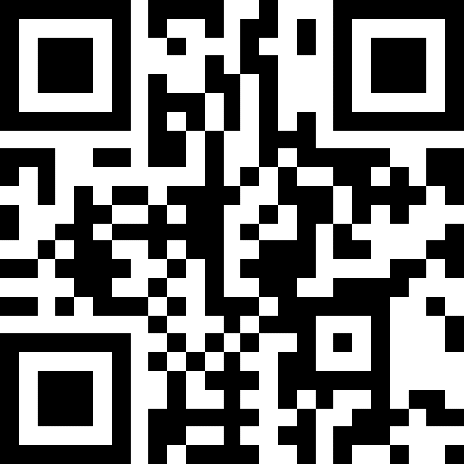
GMVEMSC is offering the opportunity to earn Continuing Education for participating in the Quarterly Triage Day (QTD). A QTD quiz will be available from December 4th to December 11th at https://tinyurl.com/QTDDEC23 or this QR code.

