EMS Job Aid
For Patients During Quarterly Triage Day (QTD)
Use the MCI Talk Group on EVERY patient transport from:
- 8 PM to midnight on the 10th
- 8 AM to Noon on the 11th
Provide only very BRIEF, MCI-style reports.
Use other communications for orders or more extensive patient reports.
Assess and treat the patient
Select a SALT Triage Category based on actual patient condition
Attach the appropriate color Triage Ribbon to EVERY EMS Patient
Remember: the MCI Talk Group has no alert tones and is used by ALL EDs.
EMS MUST clearly announce what facility you are calling, and plan to announce the ED name repeatedly.
Completely fill out a GREEN Triage Treatment Tag on EVERY EMS patient:
- Put in name, gender, allergies, age, anatomical location of injuries or illness
- Put type of injury/illness in the “Injury Key”
- Add vital signs and triage category on the bottom of the Treatment Tag
On the opposite side of the GREEN Triage Treatment Tag, indicate:
- EMS treatments
- Department and Unit # (e.g., Wash. Twp. FD Medic 17) at the top of the Notes section
- Brief notes (similar to what you would do in an actual MCI)
Use the Triage Ribbon to attach the GREEN Triage Treatment Tag
Detach the Treatment Tag tear-offs for your EMS agency’s records
If available for your EMS agency, scan EVERY patient’s Treatment Tag into Juvare EMTrack
If you have access, review the Juvare EMResource Triage Categories for hospitals in your area (same web page now used to indicate Hospital Diversion)
If you don’t have access to Juvare yet, ask your supervisor to get access

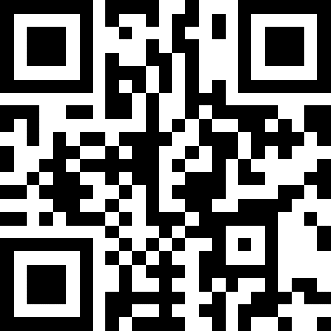
GMVEMSC is offering the opportunity to earn Continuing Education for participating in the Quarterly Triage Day (QTD). A QTD quiz will be available from December 4th to December 11th at https://tinyurl.com/QTDDEC23 or this QR code.

