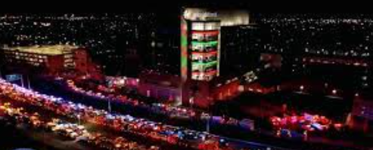
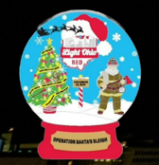

2023 Dayton Operation Santa Sleigh Check List
Saturday, December 23rd 6:00 pm to 8:00 pm
Vehicle Staging Map – University of Dayton U1 Parking Lot, behind The Marriott Hotel 1414 S. Patterson Blvd., Dayton, Ohio 45409
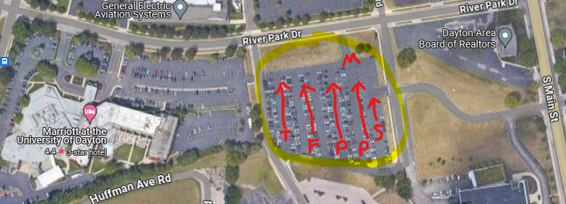
Staging
M = Motors / OSP (Traffic Lead)
S = Police Special OPS Vehicles
P = Police Cars (Marked / Unmarked equipped lights and siren)
F = Fire Vehicles
T = Tow Trucks / Public Works

Prepared by gks/12.12

