June 26, 2024
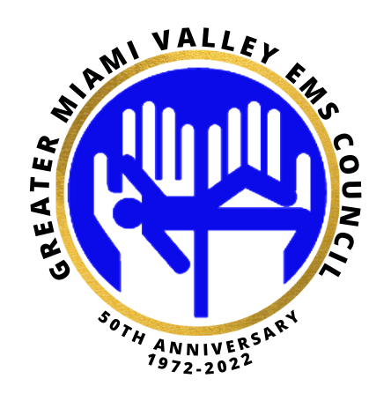
All,
We hope everyone is having a great summer! In your down time please take a minute to read the attached article from the National Conference State Legislatures office (Thanks Heidi). The next research meeting will be held hybrid on July 16, 2024 @ 10am. We will begin working on the key points to building a successful CP program and the development of protocols in the expanded role. Invitation and agenda will follow this email. If your agency has a Community Paramedicine program or is considering starting one, you need to be at this meeting! Please join us; your input is valuable to the success of Community Paramedicine as a whole.
https://www.ncsl.org/health/community-paramedics

Nancy Pook, MD FACEP,
Chair Research Committee
Greater Miami Valley EMS Council

Kendra L. Harris
Co-Chair; Research Committee
Greater Miami Valley EMS Council
Questions, please contact Kendra Harris @ 937-333-4509

