September 10, 2024

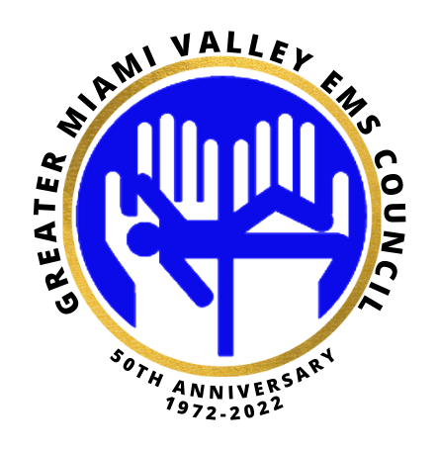

Date: Tuesday, September 17, 2024, from 10am -1130am via hybrid

Location: 124 E. Third St. GDAHA (Bombeck room)

[https://us02web.zoom.us/j/86157110421?pwd=LHnV1BOsxAE9qaeGD9dL7EpwsWucA7.1](https://gcc02.safelinks.protection.outlook.com/?url=https%3A%2F%2Fus02web.zoom.us%2Fj%2F86157110421%3Fpwd%3DLHnV1BOsxAE9qaeGD9dL7EpwsWucA7.1&data=05%7C02%7CKendra.Harris%40daytonohio.gov%7Cdf2f9d65a651479a9f3a08dcd1c3678f%7C2d3d20e325314b889c9d7d5eb039533a%7C0%7C0%7C638615884383333651%7CUnknown%7CTWFpbGZsb3d8eyJWIjoiMC4wLjAwMDAiLCJQIjoiV2luMzIiLCJBTiI6Ik1haWwiLCJXVCI6Mn0%3D%7C0%7C%7C%7C&sdata=YynXU2Jafy5dld9tEFfZIBYE8g6jYGHFXLN9sBzeLNU%3D&reserved=0)

Meeting ID: 861 5711 0421

Passcode: 355997

1. Review CHF and COPD protocols
2. How to assess a CHF/COPD patient
3. Documentation standards
4. Medication management-procurement, cost, storage
5. Implications for provider connection-telemedicine/lab
6. Non-surgical Wound care options-eg. Clozex application
7. Other considerations for development
8. Hepatitis vaccine
9. Buprenorphine protocol
10. Zyprexa protocol
11. Legislative update
12. Open discussion

**Please join us your input is valuable to the success of Community Paramedicine and continued Research of topics that can benefit all. If any questions please call 937-333-4509.**