January 15, 2025

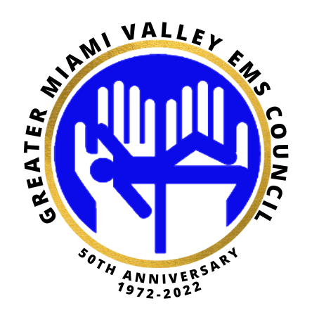

Good morning,

The next GMVEMSC Research committee meeting is scheduled for January 21, 2025 @10am. The meeting will be via zoom only this month. Please see information attached and watch for agenda to follow.

Kendra L. Harris

Co-chair; Research Committee

Greater Miami Valley EMS Council

**If any questions, please call 937-333-4509**