**Greater Miami Valley Regional Public Safety Honor Guard**

Meeting: February 25, 2025 at 1300

Our mission is to create a well-trained group of individuals in the public safety community that can assist local departments by: providing training to individuals or established teams, provide teams of trained individuals for color guards at events, and most importantly to provide local resources to aid in the event of a Line of Duty Death or other tragedy.

The team currently has approximately 30 active members that represent approximately 10 different agencies spread throughout the region. We are hoping to grow this number this year. This regional honor guard group is open to any public service member (Fire, EMS, Law Enforcement and Dispatcher) that is interested in joining. If your department only has 1 person interested, encourage them to join or at least come out and see what we are all about. No prior honor guard or military experience is required.

Trotwood Fire and Rescue is hosting this group’s first meeting of the year which is February 25, 2025 at 1300hrs at Trotwood Station 72 located at 5469 Little Richmond Rd., Trotwood Oh. 45426.

For more information or to RSVP please contact Trotwood Div. Chief Sean Lehrter at [slehrter@trotwood.org](mailto:slehrter@trotwood.org) or call 937-608-0964.

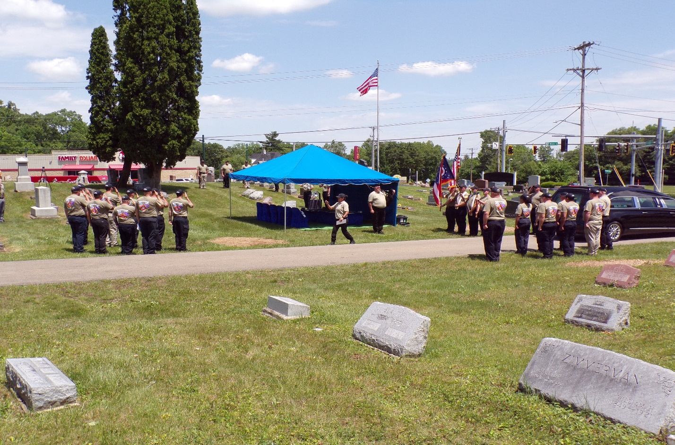

Picture from 2024 National Honor Guard Academy class hosted by Trotwood Fire and Rescue