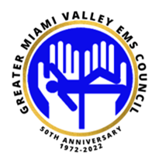

2025 GMVEMSC Protocol Review with Dr Marriott
Wednesday, April 2nd at 9am
Join Dr. Marriott as he goes through many of the changes to this year’s
GMVEMSC Protocol.


- This is the required Skills Evaluator training for this year.

- To get credit, you must complete and pass the 5-question quiz and very short evaluation. Quiz information will be at the end of the presentation.

- If you are unable to join live, you may watch the video from the same link or as soon as practical will be uploaded to the Council website.

To join the presentation, click the link or scan the QR code.
https://tinyurl.com/GMVEMSC2025


