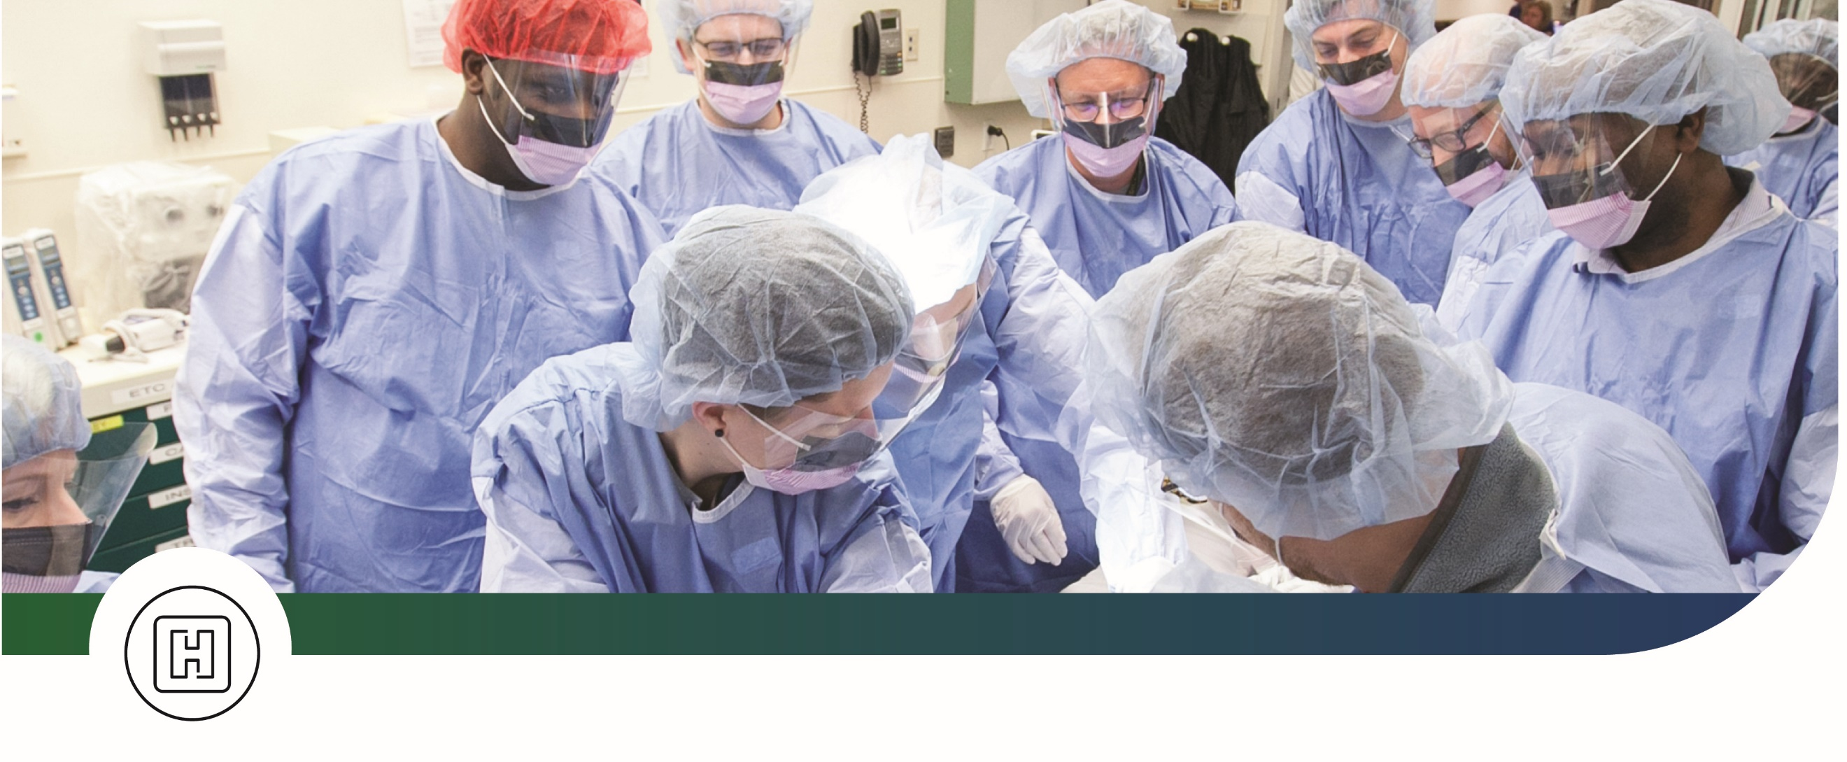
SAVE THE DATE
Trauma and Critical Care Update 2026
Friday, May 1, 2026
7 a.m. to 5 p.m.
David H. Ponitz Sinclair Center
Sinclair Community College
Building 12
444 W. Third St., Dayton, OH
This event provides current information on the challenges healthcare professionals encounter when caring for critically ill or injured patients.
Conference Topics
- Artificial Intelligence in Trauma Care
- Trauma MythBusters
- Direct Peritoneal Resuscitation
- Neuro Interventional Radiology
- Prehospital Blood
- Ultrasound in the Trauma Patient
- Submersion/Near Submersion
- Pediatric Whole Blood
- More topics to come…


Register Now

questions
Contact: Lyndsey Johns
Miami Valley Hospital
Trauma Outreach Coordinator

Call
(937) 208-4628

Email
lyajohns@premierhealth.com

