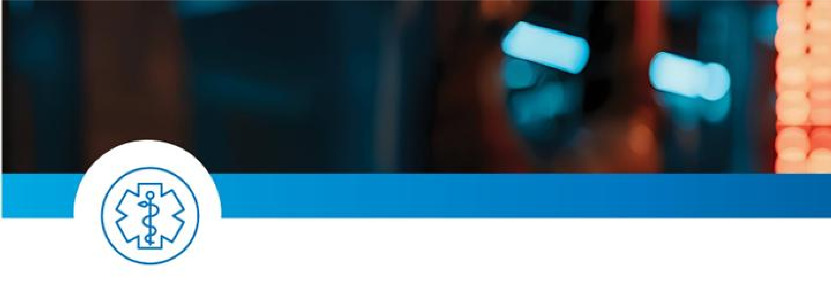

RED Phone UPDATE:

Miami Valley North RED Phone line has been temporarily forwarded to another line. EMS will still call the number listed in protocol; there has not been a change to the number.

Our IT/Telecom department recognizes this is a priority line and we are working with Frontier to get it restored.

Thank you for your understanding.

Paula Balcom, EMSFO.S.AAS, Paramedic, FESI-II, FFII, FSI
EMS Coordinator, EMS Center of Excellence
Community Paramedicine Coordinator, Premier Health


