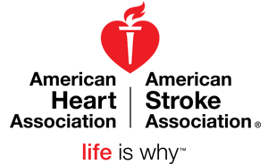

ADVANCED CARDIAC LIFE SUPPORT (ACLS)
Update/Re-Cert
WHEN:
August 18, 2017
TIME:
08:00 – 16:00
LOCATION:
Versailles EMS
320 Baker Rd.
Versailles, OH 45380
COST:
$50.00
TO REGISTER:
Matt Harvey
937-526-4899
matthewharvey@versaillesohio.cc

