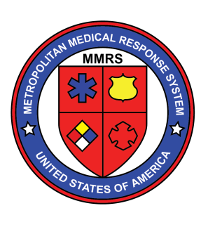
REGISTER NOW

- WHEN: Tuesday, November 14th, 2017
  - Option to attend morning, afternoon, or both
  - Breakfast, plus lunch with our speakers
  - Continuing Education, food and venue courtesy of:

- WHERE: Bieser Auditorium, Berry Women’s Center, Miami Valley Hospital, Dayton, OH
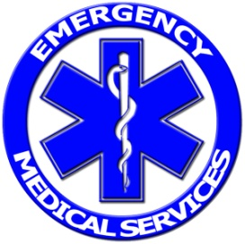
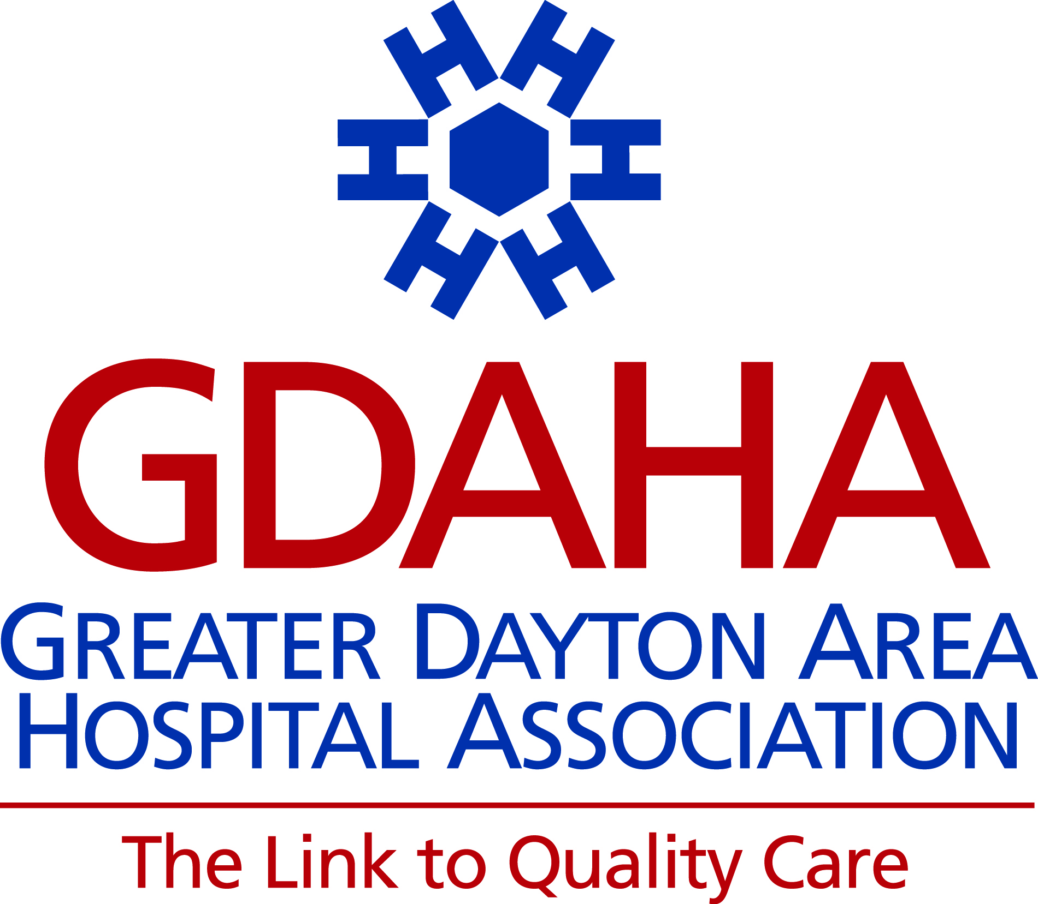
- WHO SHOULD ATTEND:
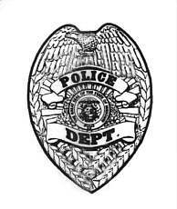
  - Law Enforcement
  - Hospitals
  - EMS
  - Fire Departments
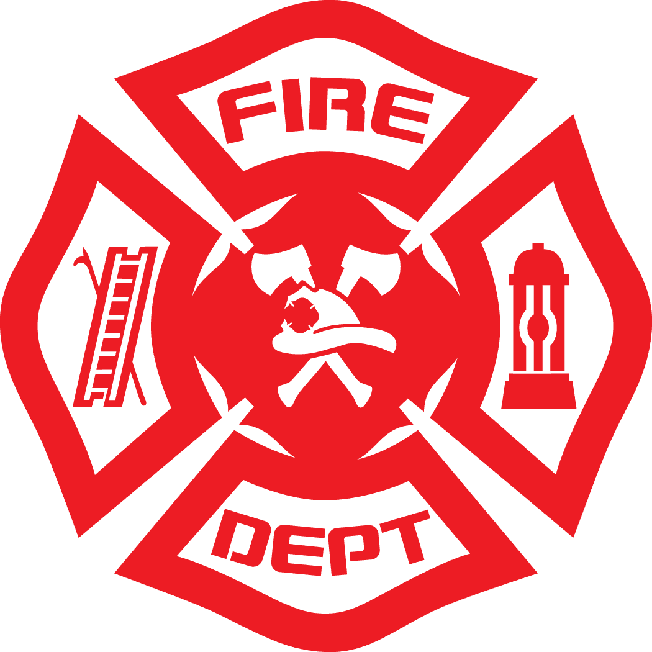
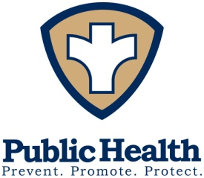
  - Public Safety Dispatchers
  - EMAs
  - Coroners
  - Public Health
- WHY? GREAT Presentations including:
    - Aurora, Colorado Active Shooter Incident Review by Lt. Sam McGhee, Aurora Police Department
    - Responses to YOUR questions about ASPR and CMS from Rick Hunt, MD, the Senior Medical Advisor at HHS ASPR
    - DHS Intelligence Report
    - Our Region’s Reports from MMRS/RMRS, Public Health, Hospital, & the FBI WMD SA
YOU MUST SIGN UP TO ATTEND:
- To register, either scan the code or click the link below:
https://www.surveymonkey.com/r/MMRS2017Steering
- SEATING IS LIMITED – sign up now!

