John R. Kasich, Governor
John Born, Director
 | - Bureau of Motor Vehicles | 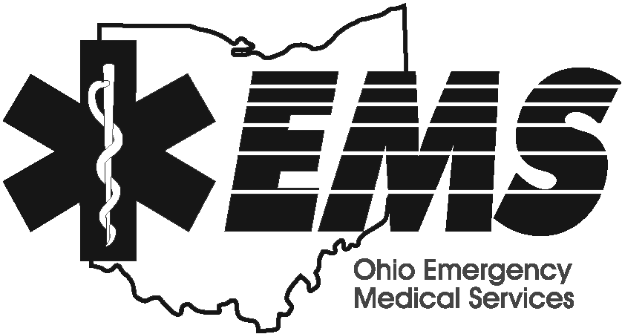 | Melvin R. House
 | - Emergency Management Agency |  | Executive Director
 | - Emergency Medical Services
 | - Office of Criminal Justice Services |  | Emergency Medical Services
 | - Ohio Homeland Security |  | 1970 West Broad Street
 | - Ohio State Highway Patrol |  | P.O. Box 182073
 |  |  | Columbus, Ohio 43218-2073
 |  |  | (614) 466-9447 (800) 233-0785
 |  |  | www.ems.ohio.gov

May 9, 2018

Dear EMS/Fire Provider,

The Ohio Division of EMS and the Homeland Security committee of the EMFTS Board, in conjunction with the Ohio Department of Health, has provided a new/updated CHEMPACK training for Healthcare Providers and First Responders in the State of Ohio.

CHEMPACK is a presentation that will eventually be web based but is being taken out to (9) areas throughout May and June to educate EMS, Fire, Host and Non Host Hospitals, Non Host Hospital Administrators, Law Enforcement Personnel, Dispatchers and Public Health personnel on how to access additional supplies and medications that will be needed in the event of a large scale chemical exposure or attack. The CHEMPACK presentation will be provided at the beginning of each session. This session is recommended but not required, and is expected to take approximately 90-120 minutes.

Following the question and answer period for CHEMPACK, the Division of EMS will be providing information and an update on EMS items within the State of Ohio. This 45-60 minute presentation is optional, but will provide interested parties information about recent changes within the rules and curriculum requirements. There will also be an opportunity to have any questions addressed.

The sessions are listed on the next page along with the registration person and contact information for each location. There is a large amount of seating available but it is limited. Please register to ensure your space.

Please contact me should you have any questions regarding the content.

Date | Time | Location | Registration Person | Contact information
5/25/18 | 12p-4p | ODOT | Kris Miller | camiller1@dps.ohio.gov
5/30/18 | 12p-4p | Belmont College | Kris Miller | camiller1@dps.ohio.gov
6/4/18 | 12p-4p | Great Oak Career Campus | Kris Miller | camiller1@dps.ohio.gov
6/5/18 | 12p-4p | Miami Valley Career Technology Center | Kris Miller | camiller1@dps.ohio.gov
6/6/18 | 10a-2p | Holzer Medical Center (Jackson) | Kris Miller | camiller1@dps.ohio.gov
6/11/18 | 12p-4p | Vantage Career Center | Jackie Brandt | 419-203-1924  jbrandtwern727@gmail.com
6/13/18 | 12p-4p | Lakeland Community College | Debbie Hermetet | 440-525-7022, dhermetet1@lakelandcc.edu
6/19/18 | 12p-4p | Vanguard-Sentinel Career and Technology Center | Lorrie Dymond | 419-332-2626 ext 2731  ldymond@vsctc.org
6/21/18 | 12p-4p | Stark State College | Jeri Quinn | Jquinn@starkstate.edu  BStich@starkstate.edu

Thank you.

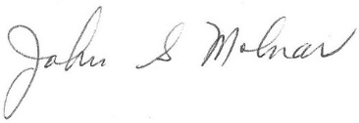
John S. Molnar, BA, NREMT-P
Chief, Education and Testing
614.387.0649 (Office) 614.466.9461 (FAX)
jsmolnar@dps.ohio.gov

Division of Emergency Medical Services
Ohio Department of Public Safety
1970 West Broad Street, PO Box 182073
Columbus, Ohio 43218-2073

What will you do today to contribute to a safer Ohio?

