Retiring
After
34 Years
All ARE WELCOME TO JOIN US AS WE HONOR
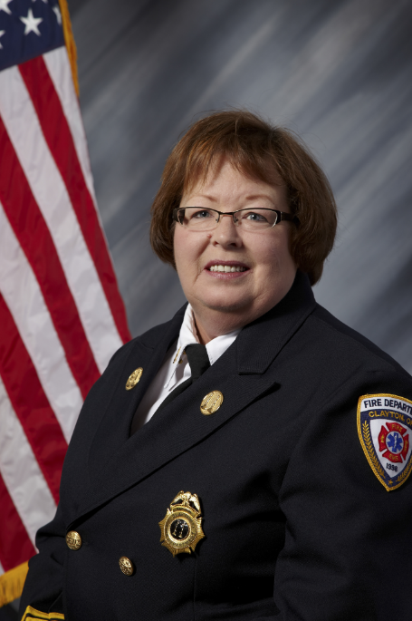
Battalion Chief Paula Creech
Tuesday July 17th, 2018
1:00 Pm to 4:00 PM
AT MEADOWBROOK OF CLAYTON
6001 SALEM AVE. CLAYTON, OH 45315

