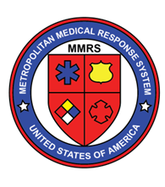  annual dayton mmrs/rmrs steering committee meeting  November 13th, 2018  8:00AM – 12:30PM  Breakfast Preceding, Lunch Following  Bieser Auditorium in the Berry Women’s Center, Miami Valley Hospital  One Wyoming Street, Dayton, OH 45409  Who Should Attend?  - Law Enforcement  - Hospitals  - EMS  - Fire Departments  - Public Safety Dispatchers  - EMAs  - Coroners  - Public Health  Why? GREAT Presentations including:  - One October: 2017 Las Vegas Shooting presented by Las Vegas Metropolitan Police Department  - Las Vegas Attack presented by AMR, Nevada Operations  - Cincinnati Fifth Third Center Active Shooter Incident  - Upcoming Exercise Plans  - Our Region’s Reports from MMRS/RMRS, Public Health, Hospitals, DHS, & the FBI | Continuing Education, food, and venue courtesy of:  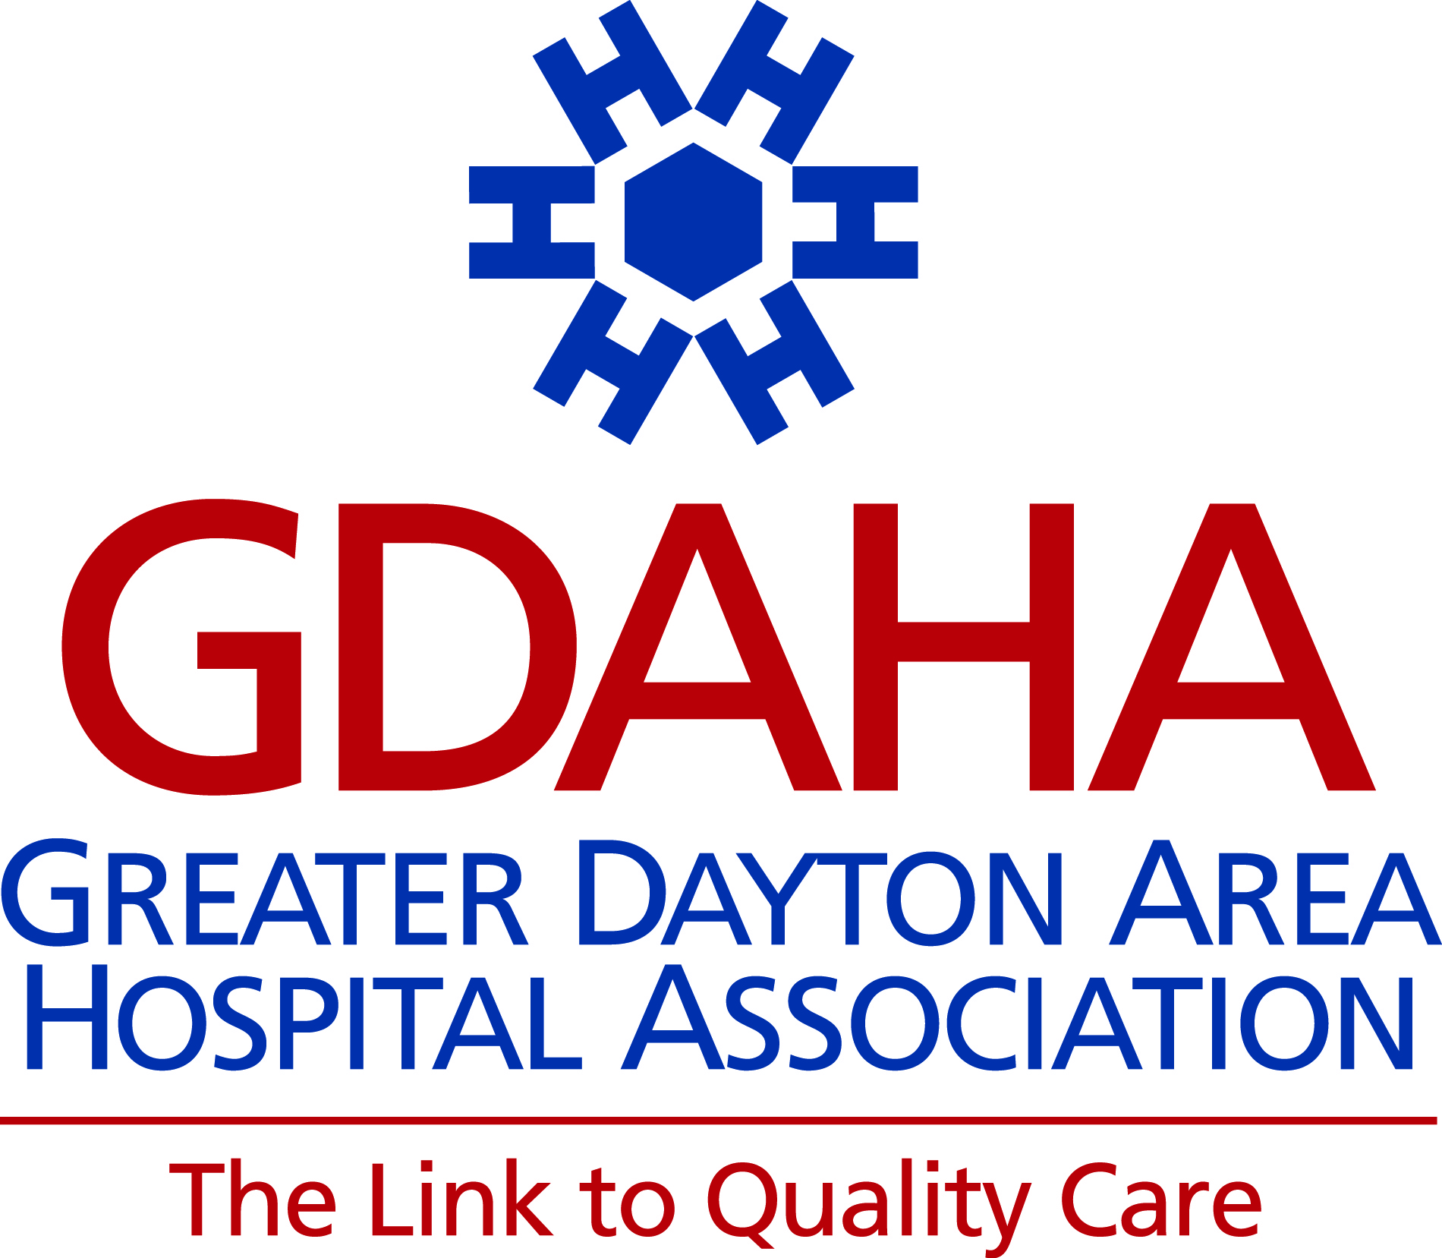  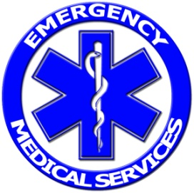  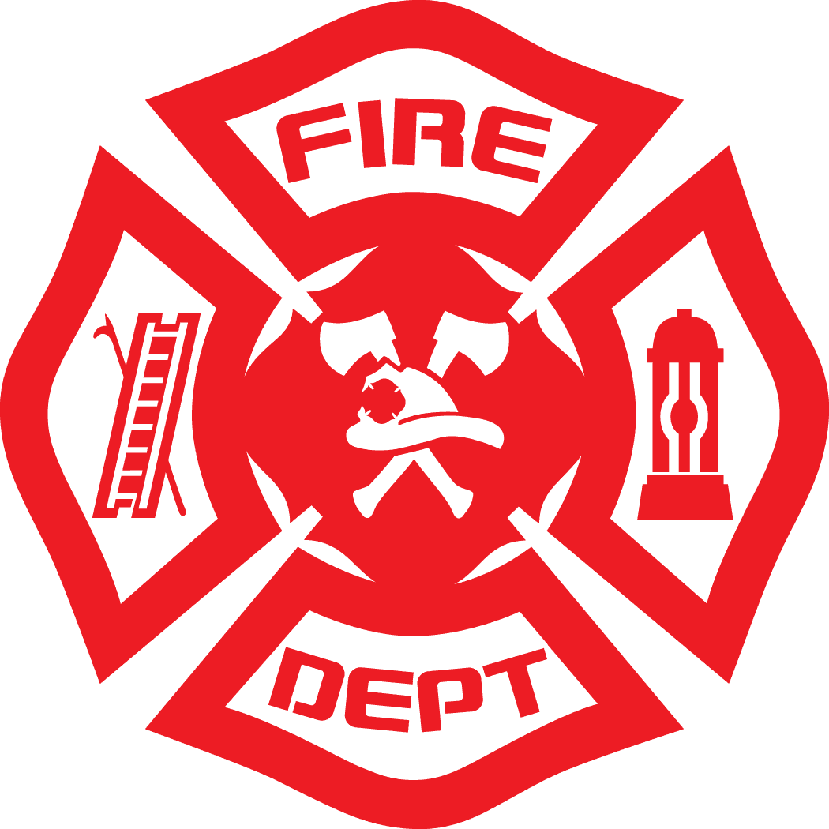  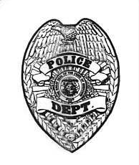  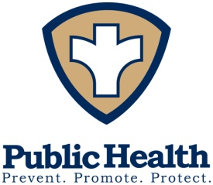  Seating is limited! REGISTER NOW  https://www.surveymonkey.com/r/STEERINGMMRS2018

