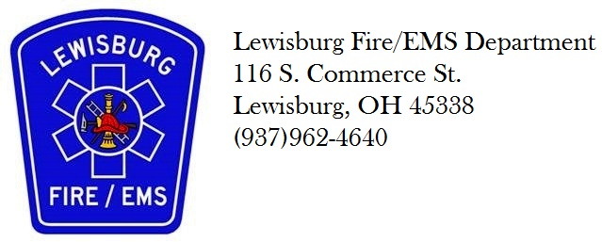

Lewisburg Fire/EMS, Located in Eastern Preble County, is accepting applications and/or resumes for Part Time FF/Paramedic. We are looking for an every 3rd day or every 6th day positions and fill in positions.
Shift times are 0800-1800.
Qualifications:
Candidates must hold a State of Ohio Fire Fighter Level 1 card, level II is preferred.
Valid State of Ohio EMT-Paramedic.
Must possess and maintain a valid Ohio driver license and remain insurable under the Lewisburg Fire/Ems vehicle insurance plan.
Successful completion of a background check through Ohio BCI and FBI.
All applicants will be subject to a pre-hire drug screen.
Pay rate is $12.50/hour
Application can be picked up at the firehouse located at
116 South Commerce Street
Lewisburg, Ohio 45338
Resumes can be e-mailed to lewisburgfire@bizwoh.rr.com and applications can be picked up at 116 South Commerce street Lewisburg, Ohio 45338

