Department: Fire Department
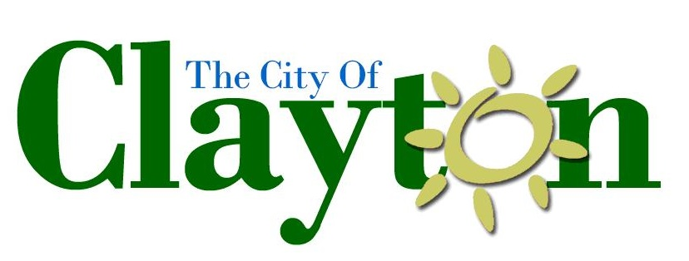

Rev/Est: 07-16

Job Code:

FLSA Status: Exempt

Career Firefighter/Paramedic

GENERAL PURPOSE

To perform fire and emergency medical services as well as a variety of technical and administrative work in assisting the implementation of fire prevention, suppression and emergency medical services to prevent or minimize the loss of life and property by fire and emergency medical conditions.

ESSENTIAL FUNCTIONS OF THE POSITION

- Performs firefighting activities including driving fire apparatus, operating pumps and related equipment, laying hose, and performing fire combat, containment and extinguishment tasks.

- Performs emergency medical service activities including administering basic life support, advanced life support and providing other assistance as required.

- Participates in fire drills, attends classes in firefighting, emergency medical, hazardous materials and related subjects.

- Receives and relays fire calls and alarms. Operates radio and other communication equipment.

- Participates in the inspection of buildings, hydrants and other structures in fire prevention programs.

- Maintains fire equipment, apparatus and facilities. Performs minor repairs to departmental equipment.

- Performs general maintenance work in the upkeep of fire facilities and equipment: cleans and washes walls and floors, cares for grounds around station, makes minor repairs, washes, hangs and dries hose, and other equipment and facilities related task.

- Assists in developing plans for special assignments such as emergency preparedness, hazardous communications, training programs, firefighting, hazardous materials and emergency medical service activities.

- Present programs to the community of safety, medical and prevention topics.

- Performs salvage operations such as throwing salvage covers, sweeping water, and removing debris.

OTHER DUTIES AND RESPONSIBILITES

- Assists in department supervisory and administrative activities as assigned.

- Assists in training new employees as assigned.

- Other duties as determined appropriate by the Fire Chief.

Necessary Knowledge, Skills and Abilities:

- Considerable knowledge of modern fire suppression and prevention as well as emergency medical service principles, procedures, techniques, tactics and equipment.
- Working knowledge of first aid and resuscitation techniques and their application as demonstrated through State Paramedic Certification.
- Considerable knowledge of applicable laws, ordinances, departmental standard operating procedures and regulations.
- Skill in the operation of required tools and equipment.
- Ability to perform a variety of strenuous work activities requiring good physical condition.
- Ability to communicate effectively orally and in writing.
- Ability to exercise sound judgment in evaluating situations and in making decisions.
- Ability to effectively give and receive verbal and written instructions.
- Ability to establish and maintain effective working relationships with other employees, supervisors and the public.
- Ability to meet the special requirements listed below.

TOOLS AND EQUIPMENT OPERATED

Emergency medical ambulance, fire apparatus, fire pumps, hoses, and other standard firefighting equipment, ladders, first aid, basic and advanced life support equipment, radio, MDT, pager, personal computer and phones.

INHERENTLY HAZARDOUS OR PHYSICALLY DEMANDING WORKING CONDITIONS

The physical demands described here are representative of those that must be met by an employee to successfully perform the essential functions of this job. Reasonable accommodations may be made to enable individuals with disabilities to perform the essential functions.

While performing the duties of this job, the employee is frequently required to sit; talk or hear; stand; walk; use hands to finger, handle, or operate objects, tools, or controls; and reach with hands and arms. The employee is occasionally required to climb or balance; stoop, kneel, crouch, or crawl; and taste or smell.

The employee must frequently lift and/or move up to 10 pounds and occasionally lift and/or move up to 100 pounds. Specific vision abilities required by this job include close vision, distance vision, color vision, peripheral vision, depth perception, and the ability to adjust focus.

WORK ENVIRONMENT

The work environment characteristics described here are representative of those an employee encounters while performing the essential functions of this job. Reasonable accommodations may be made to enable individuals with disabilities to perform the essential functions.

Work is performed primarily in office, vehicles, and outdoor settings, in all weather conditions, including temperature extremes, during day and night shifts. Work is often performed in emergency and stressful situations. Individual is exposed to hearing alarms and hazards associated with fighting fires and rendering emergency medical assistance, including smoke, noxious odors, fumes, chemicals, liquid chemicals, solvents and oils.

The employee occasionally works near moving mechanical parts and in high, precarious places and is occasionally exposed to wet and/or humid conditions, fumes or airborne particles, toxic or caustic chemicals, risk of electrical shock, and vibration.

The noise level in the work environment is usually quiet in office settings, and loud at an emergency scene.

LICENSURE OR CERTIFICATION REQUIREMENTS

- High School Diploma /GED or equivalent
- Level II Firefighter
- Paramedic
- Valid Ohio Driver’s License
- NIMS certifications

