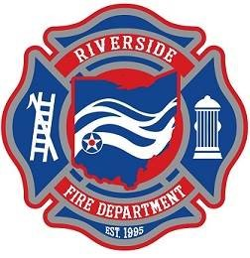

Application available: https://www.riversideoh.gov/government/careers/

The City of Riverside is accepting applications for Part-time Firefighter. Under general direction, performs specialized work with regard to protecting life and property through fire suppression, fire prevention and emergency medical services and may assist with fire inspection and code enforcement duties related to the position of Fire Inspector. Minimum qualifications include Ohio certificate for EMT-Basic and Firefighter I, Current Ohio Driver’s license, NIMS 100 and 700. Pay Range is $10.00 – $15.00 / hour. Applicants agreeable to working 24 hours every 6th day preferred. Continuing Education, working with state of the art equipment, and a fast pace, exciting experience all included. Apply Today!

The City of Riverside is an equal opportunity employer.

Riverside F.D. is hiring!

Part-time Firefighter /EMTs

$10.00 – $15.00/Hr.*
*Depending on certifications & schedule commitment
City of Riverside Fire Department
5200 Springfield St. Ste. 100
Riverside OH 45431
937-233-1801
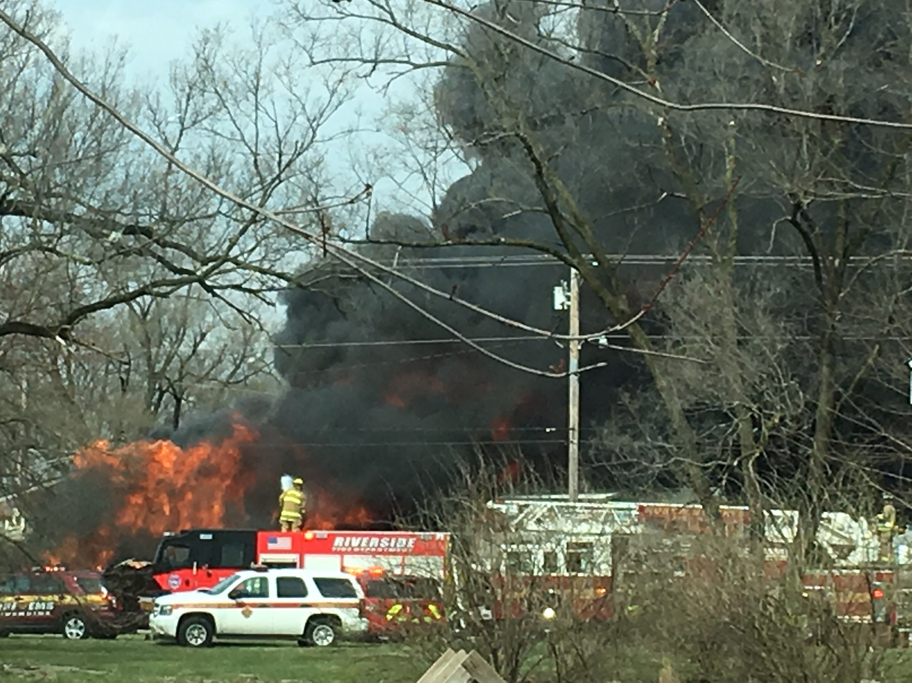
- We are looking to fill several positions!
- Orientation pay is $10.00 / hour.
- Commitment to work a shifted (24 every 6th) schedule receives shifted incentive pay.
- Driver operator status pay increase

