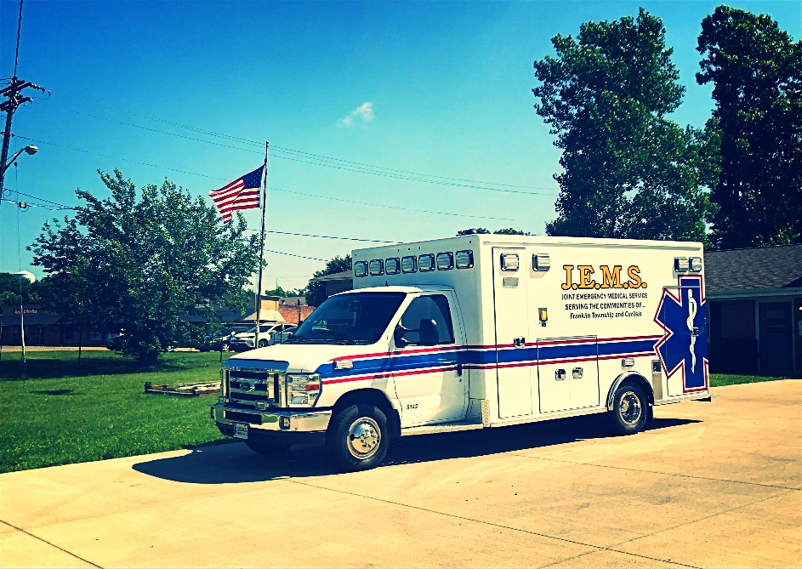
Joint Emergency Medical Service (JEMS)
Is Hiring EMTs and PARAMEDICs
We are an EMS Only/Non-Fire Department based agency that provides 911 ALS/BLS service to
Franklin Township & Carlisle in Warren County.
EMT pay = $12/hour
PARAMEDIC pay = $15/hour
Double Time on recognized Holidays
$1/hour Incentive Pay for Weekends
Applications are available on our website:
www.jems15.org
or at our Headquarters Station:
201 E. 6th Street
Franklin, Ohio
45005
Questions? Call us at (937) 746-3471

