

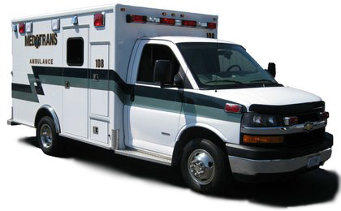***Employment Opportunity***

***Full and Part Time***

***Med-Trans, Inc. has immediate openings in both the Springfield and Dayton offices. In addition to a variety of shift options, Med-Trans offers competitive wages to qualified applicants:***

* ***EMT-Basic $19.00/hour***
* ***AEMT $20.00/hour***
* ***Paramedic $25.00/hour***
* ***Additional differential pay for both evening and premium positions***

***Med-Trans will also be offering sign-on bonuses for applicants applying for Full Time positions only. Bonus will be paid each quarter of the year after 90-day qualifying period.***

* ***EMT & Advanced EMT $5,000.00***
* ***Paramedic $7,000.00***

***Med-Trans has been providing private EMS to the Miami Valley for the last 42 years, fostering wonderful relationships with the community and partnering with other local healthcare leaders. These partnerships offer exciting opportunities to our employees including EMT and Paramedic positions within our Ohio Hospice of Dayton Division.***

***Interested applicants can apply in person at either our Springfield or Dayton office. You may also download and print an employment application from our website:*** [***http://www.med-trans.com/***](http://www.med-trans.com/) ***and click on employment opportunities. Once completed, you can scan and email the application to:*** [***employment@med-trans.com***](mailto:employment@med-trans.com) ***, and our Human Resource department will contact you to discuss interview options.***