City of Franklin
Firefighter/Paramedic

If you understand our priority to put our community first by delivering loyal and compassionate fire and rescue services, and operating with the highest level of responsibility and ethics, while innovating for the future, this is the right opportunity for you!
Compensation & Benefits: Pay Rate: $65,262.08 - $70,333.12 + 10% Pension Pick-Up and competitive benefits package including health, dental, optical and life insurance, and generous paid time off. Effective March 26, 2023, additional bonus of $1.00 for each hour work is available under the terms of the Wages and Certification MOU through October 11, 2024.

Qualifications: Must possess a certificate under ORC 4765.55 evidencing satisfactory completion of a firefighter training program and a valid certificate issued under ORC 4765.30 to practice as a Paramedic. Candidates must also be at least 18 years of age, have a High School Diploma or GED and must possess a valid Ohio Driver’s License.
Application Process: STEP 1: Completed applications, resumes, accompanying certifications, written test results, and proof of satisfactory physical ability test results will be accepted through Tuesday, August 22, 2023, 3:59 pm. Applications are available at Franklin City Municipal Building and at https://www.franklinohio.org/jobs. Completed applications will be accepted at the City Building or by email at cchibis@franklinohio.org.
STEP 2: Written Test. Schedule a Written [Electronic] Test at www.nationaltestingnetwork.com or Submit Test Scores for test taken between August 22, 2022, and August 22, 2023.
STEP 3: Physical Ability Test. If you possess a valid CPAT or Firefighter Mile certificate issued no earlier than August 22, 2022, from a licensed CPAT or NTN provider, that certificate will be accepted in lieu of completing the Physical Ability Test. If you submit proof of completion of the Firefighter Mile or CPAT, you do not have to attend the testing dates provided below.

MORNING TESTING OPPORTUNITES EVENING TESTING OPPORTUNITITES
Tuesday, August 15, 2023 – 9 AM Friday, August 18, 2023 – 7 PM
Call Lt. Katie Williams at 937-746-4542 Ext 1600 to SCHEDULE Firefighter Mile Testing at least 24-hours BEFORE reporting for Firefighter Mile Exam.

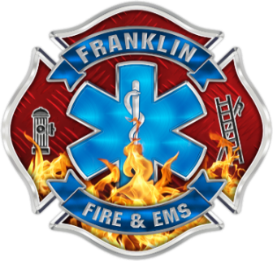
Ready to get started?
Click here for more information:
www.FranklinOhio.org/Jobs

