City of Franklin
Firefighter/Paramedic – Lateral Entry

If you understand our priority to put our community first by delivering quality public service, and operating with the highest level of responsibility and ethics, while innovating for the future, this is the right opportunity for you!
Compensation & Benefits: Pay Rate: $65,262.08 - $70,333.12 + 10% Pension Pick-Up and competitive benefits package including health, dental, optical and life insurance, and generous paid time off. Effective March 26, 2023, additional bonus of $1.00 for each hour work is available under the terms of the Wages and Certification MOU through October 11, 2024.
Qualifications: Must be currently employed as a full-time Paramedic for a public entity, be at least 18 years of age, have a High School Diploma or GED and must possess a valid Ohio Driver’s License.
Application Process: Completed applications, resumes, and accompanying certifications will be accepted through Tuesday, August 22, 2023, 3:59 pm. Applications are available at Franklin City Municipal Building and at https://www.franklinohio.org/jobs. Completed applications will be accepted at the City Building or by email at cchibis@franklinohio.org.

Selection Process: The selection process will include a qualification review, valued at 50% of selection score, and an oral interview, valued at 50% of selection score.
Qualification review to include the following:
      - Ohio Paramedic Certification = 70 points
      - Ohio Firefighter Certification = 20 points
      - Years of FT FF/Paramedic Service = 2 points per year
      - Veteran Credit = 5 points
      - Bachelor’s degree = 4 points
      - Associates degree = 2 points

Minimum acceptable score = 70 points
Maximum score = 100 points
The cumulative score will be certified by the Civil Service Commission
who will provide the Division with the top ten applicants for selection.

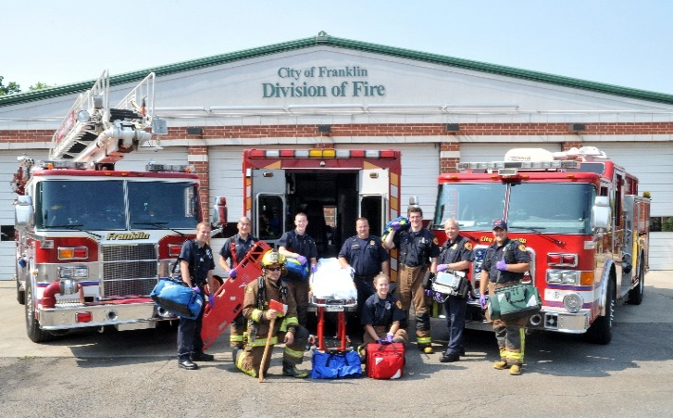

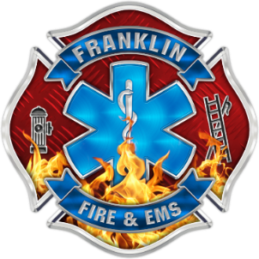
Ready to get started?
Click here for more information:
www.FranklinOhio.org/Jobs

