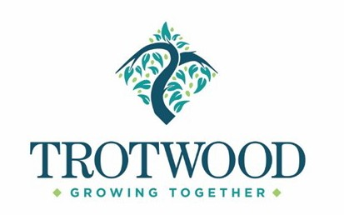
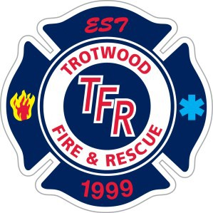
The City of Trotwood Fire Department is accepting internal and lateral applications until Friday, September 15, 2023 at 4pm EST for the position of Career Fire/EMS Lieutenant to create an eligibility list for that position.

Salary range:
$69,858.88-77,051.52

Additional Benefits:
- Holiday Bonus of 216 hours of pay
- $700 PARAMEDIC Educational Stipend
- Health Insurance City pays 87% of premium for core coverage
- Paid Vacation Time
- 24 hrs. of Personal Time per yr. (after 1st yr. of employment)

Minimum Qualifications:
- High school graduate or equivalent required.
- Up to $250 Physical Fitness Stipend
- City Paid $50,000 Life Insurance Policy
- $150 Boot Allowance every 2 years
- Up to 5 PAID Earned Days Off (EDO) per year
- Holiday Pay for holidays worked

- US citizen & 18 years of age to apply with a valid driver’s license (with less than 6 points).
- Minimum of three (3) years of cumulative FULL-TIME fire service experience.
- State of Ohio Firefighter II & Paramedic Certification (at time of application).
- Completion of F.O. I & II that meets or exceeds NFPA 1021 Fire Officer Professional Qualifications (at time of application).
- State of Ohio Fire Instructor certification OR EMS Instructor certification that meets or exceeds NFPA 1041: Fire Service Instructor Professional Qualifications (at time of application).
- State of Ohio Fire Safety Inspector certification (at time of application).
- Associate’s Degree or equivalent from a two-year college or technical school with major course work in Fire Science or a related field and/or advanced technical training in Fire Science is desirable or any combination of education, training, and experience which provides the required knowledge, skills, and abilities to perform the essential function of the job.
- Pass the written exam with a minimum passing score of 70%.
Instructions for written testing registration for entry level candidates
Fire Lieutenant candidates must take the civil service written test through the Public Service Testing Associates, LLC (PSTA) at the Trotwood Community & Cultural Arts Center: 4000 Lake Center Dr, Trotwood, OH 45426. Date/Time: Saturday, September 16, 2023, 9:00 am at the Trotwood Community & Cultural Arts Center, 4000 Lake Center Dr, Trotwood, OH 45426.
The study material for this position may be obtained from the Human Resources Department at the Trotwood Government Center 3035 Olive Rd., Trotwood, OH 45426. Please note: Lateral do not need to take the test.

The application packet for this position may be obtained from the Human Resources Department at the Trotwood Government Center 3035 Olive Rd., Trotwood, OH 45426 or completed online at www.trotwood.org (HR page).

The city of Trotwood complies with Equal Employment Opportunity (EEO) laws and regulations. Furthermore, the City of Trotwood considers qualified applicants for positions without regard to race, color, religion, creed, gender, national origin, age, disability, marital or military/veteran status, genetic information, or sexual orientation.
Application, copies of all applicable certifications, DD214 form, cover letter, and resume must be submitted to Human Resources, Friday, September 15 2023.EST.

