Lateral and Entry Level

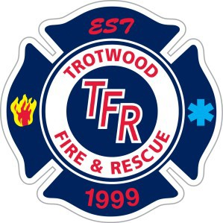
The City of Trotwood Fire Department is accepting applications until Friday, September 15, 2023 at 4pm EST for the position of Entry Level and Lateral Firefighter/Paramedic and Firefighter/EMT and to create an eligibility list for both positions.

Salary range:
Firefighter/EMT is $49,882.56 to $65,723.84/yr. Firefighter/Paramedic is $53,060.80 to $69,971.20/yr.

Additional Benefits:
- Holiday Bonus of 216 hours of pay
- $700 PARAMEDIC Educational Stipend
- Health Insurance City pays 87% of premium for core coverage
- Paid Vacation Time
- 24 hrs. of Personal Time per yr. (after 1st yr. of employment)

Minimum Qualifications:

- Up to $250 Physical Fitness Stipend
- City Paid $50,000 Life Insurance Policy
- $150 Boot Allowance every 2 years
- Up to 5 PAID Earned Days Off (EDO) per year
- Holiday Pay for holidays worked
- US citizen & 18 years of age to apply with a valid driver’s license (with less than six (6) points).
- High school graduate or equivalent required
- Eye sight correctable to 20/20.
- State of Ohio Firefighter II certification (at time of appointment).
- State of Ohio certification at EMT level (at time of application) (Paramedics will receive preference).
- Ability to obtain State of Ohio Fire Inspector certification within one (1) yr. of appointment.
- CPAT or Kettering Sports Medicine “Firefighter Mile Physical Abilities Test” current at time of application (Entry Level).
- Achieve a passing score of 70% on the National Testing Network written examination at time of application (Entry Level).

How to Apply:
Applications must be submitted to Human Resources by Tuesday, September 15, 2023 at 4:00 PM EST.
The city of Trotwood complies with Equal Employment Opportunity (EEO) laws and regulations. Furthermore, the City of Trotwood considers qualified applicants for positions without regard to race, color, religion, creed, gender, national origin, age, disability, marital or military/veteran status, genetic information, or sexual orientation.
Entry level candidates must take the civil service written test through the National Testing Network (NTN). This is a virtual testing process.
- Please note: Lateral do not need to take the test.

