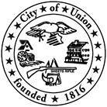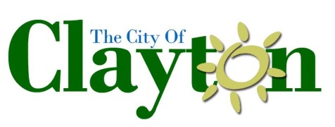
JOB OPPORTUNITY
The Clayton, Englewood and Union Fire Department Collaborative is currently accepting applications for a full-time Fire Inspector.

JOB TITLE: FIRE INSPECTOR – Full-Time – Salary, Non-Union
DEPARTMENT: City of Clayton, Englewood, and Union (Montgomery County) Fire Department Collaborative
POSITION DESCRIPTION: Under the direction of the Fire Chiefs, performs all functions associated with fire safety inspections, fire prevention and public education.
SALARY RANGE (starting): $60,000-$80,000 annually DOQ Certifications and Experience.
REQUIRED QUALIFICATIONS: At the time of application, applicant must possess and provide copies of the following: (1) High School; Diploma (2) Firefighter II- State of Ohio, (3) EMT-State of Ohio, (4) CPR certified, (5) Certified Fire Safety Inspector, (6) Plans review course (or obtained within 6 months of hire), (7) Public Educator 1 (or obtained within 1 year of hire)
PREFERRED QUALIFICATIONS: (1) Public Educator II, (2) NAFI CFEI or IAAI CFI, (3) Juvenile fire setter training, (4) ICC fire plans examiner, (5) NFPA certified fire protection specialists, (6) Associate Degree, (7) Bachelors Degree
Must possess and maintain a valid Ohio driver’s license and remain insurable under the City’s vehicle insurance plan.
TO APPLY: Apply in person at the Clayton Governmental Offices at 6996 Taywood Road, Englewood Ohio 45322 or download and complete all required materials online at www.clayton.oh.us and return in person or by mail to HR Administrator Elaine Wittman, with a resume and cover letter. It must be received by the stated deadline, or it will not be reviewed during the first consideration.
APPOINTMENT PROCEDURE: Selection process includes: a review of cover letter and resume. Those considered will be contacted for an oral interview. Prior to appointment, candidate must submit to background investigation and drug screen.
POSTING DATE: May 24, 2024

CLOSING DATE: June 10, 2024, at 4pm

An Equal Opportunity Employer

