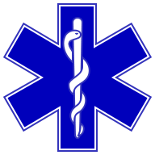
Want to make a difference in your community?

You can!

The Fort Loramie Rescue Squad is still currently looking for new members.

Joining is easy, exciting, and gives you a great feeling of accomplishment.

You start out as an observer. This means you will be able to ride along and experience what we do. You can then decide if you’d like to begin the training to pursue your EMT certification. All training expenses are paid.

Membership requirements are:
You must be 18 years of age
Must have a valid drivers license
Have a high school diploma

For more information, call at 937-295-2980,
E-mail flrschief@nktelco.net, loramierescue@gmail.com or contact a squad member you know.

Make a difference, Volunteer!

