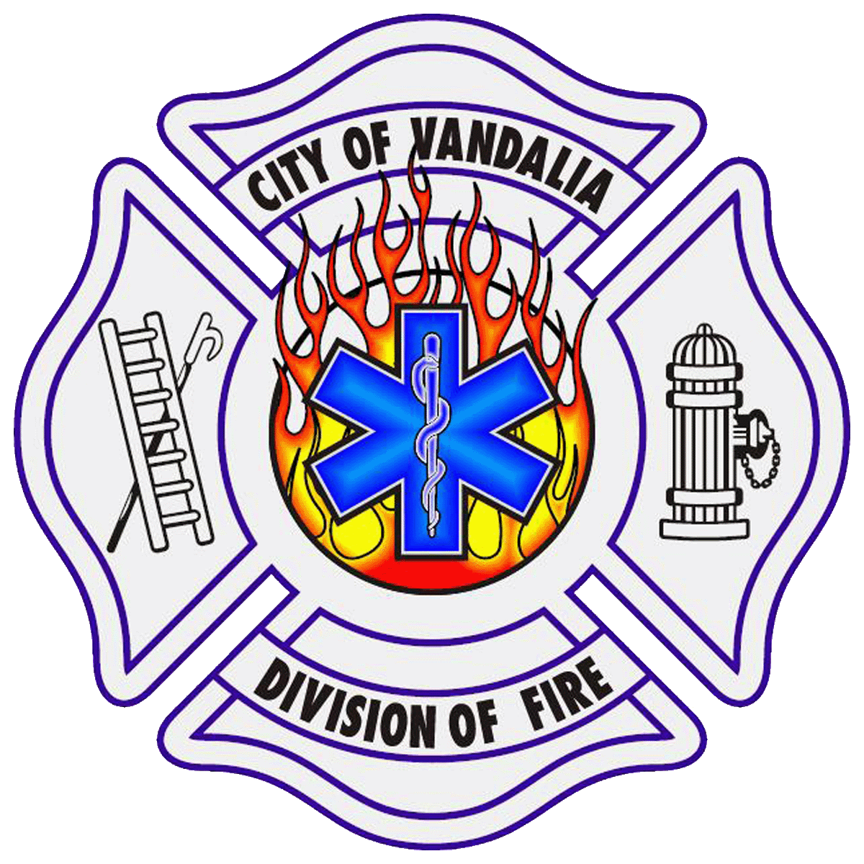
Vandalia Division of Fire
Firefighter/Paramedic/Fire Inspector

With a tradition of service excellence, the City of Vandalia is accepting applications for Full Time Entry Level Firefighter/Paramedic/Fire Inspector.
Applicants must meet the following:
- 18 years old
- U.S. Citizen
- Valid Ohio driver’s license
- Ohio Level II Firefighting certification
- Ohio Paramedic certification
- EVOC --Emergency Vehicle Operator Course
The following qualifications are preferred:
- Associate's Degree or 2 years’ college credit
- At least one year of recent, successful service—full or part time---
as a Firefighter/Paramedic
- Ohio Fire Safety Inspector certification (MUST be obtained within one year if appointed)

Current base salary is $48,438; outstanding benefits package.
Applications and IMPORTANT qualification instructions available at www.vandaliaohio.org. Application deadline is Thursday, June 15, 2017 at NOON.
Vandalia is EOE and ADA compliant. Women/minorities encouraged to apply.

