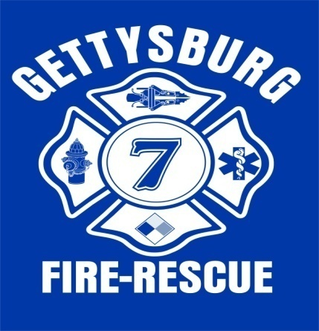
Gettysburg Rural Fire Dept., Inc.
215 Factory Street
P.O. Box 281
Gettysburg, Ohio 45328
Phone (937) 447-2121
Fax (937) 447-4611
E-mail – grfd7@earthlink.net

NOW HIRING
The Gettysburg Rural Fire Dept., Inc. located in Central Darke County is hiring
Part-time EMS personnel for Days, Nights and Weekends (24 Hr. shifts available)

Applications can be downloaded from our website at www.gettysburgohiofd.com
Or call (937) 447-2121 and leave a message

Qualified applicants must possess:
- A valid Driver’s License
- Have 1 year experience as an EMT
- Must be at least 18 years old and out of High School
- Have a current CPR card
- Hold a current EMT-B, EMT-I or EMT-P certification
- And not have any felony convictions.
Successful applicants will be compensated at the following rates:
- EMT-B $10.00 per hour
- EMT-I $11.00 per hour
- EMT-P $12.00 per hour
The Gettysburg Rural Fire Dept., Inc. provides EMS service to The Village of Gettysburg and surrounding townships and protects approx. 3300 citizens.
We look forward to receiving your application and becoming a member of our life saving team.

