**Premier Health**

**Advanced Stroke Care**

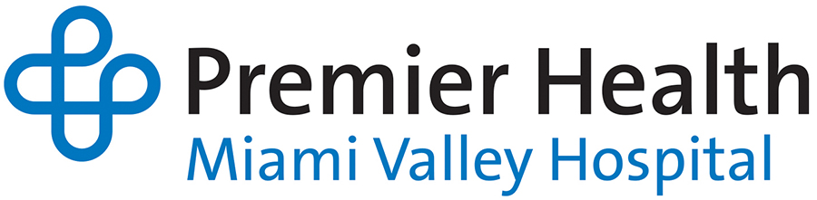

**Free Stroke Education Course**

**Miami Valley Hospital South**

**Cancer Center Conference Room B**

December 11, 2019

0800-1200

A 4 -hour course on the care of the stroke patient. This course focuses on:

* Stroke Assessment/Identification
* Stroke Imaging
* Stroke Syndromes
* Treatment Options
* Case Study Review

Break-out sessions will be provided for EMS and Nursing (ED and Bedside) specific topics and hands-on practice.

Target Audience

Nurses and EMS Providers

4 CEs are awarded to each participant

Please RSVP to Michelle Post (Telehealth Program Manager) at [mmpost@premierhealth.com](mailto:mmpost@premierhealth.com)

