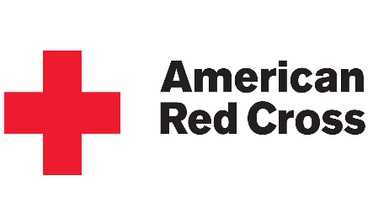

Mercury EMS Consultants provides BLS, ACLS, and PALS courses
**COMING SOON: EMT and Paramedic Refresher Courses**
Book a class online @ https://www.mercuryemsconsultants.com/book-online

BLS FOR HEALTHCARE PROVIDERS - CLASSROOM COURSES
- Monday-Thursday 9am-1pm and 2pm-6pm*
- Night Classes on Wednesday and Thursday 6pm-9pm

BLS FOR HEALTHCARE PROVIDERS – BLENDED LEARNING
- BLS for Healthcare providers Skills Verification, check website for times
- Online learning courses combined in person skills verification, book online
ACLS AND PALS - CLASSROOM COURSES
- ACLS Initial Certification/Renewal Courses-classes are Friday 9am-5pm**
- PALS Initial Certification/Renewal Courses-classes last Friday of the month 9am-5pm

* No afternoon classes on Wednesdays
**No ACLS class the last Friday of the month
***Due to Covid-19, Mercury is practicing social distancing in our training center and is offering PPE to clients.

