About Your EMS Call 11/20
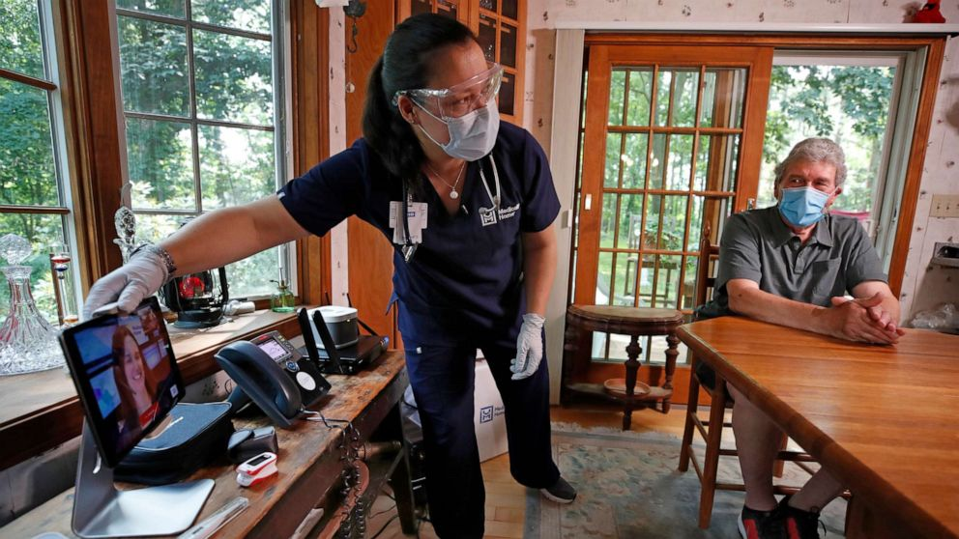
You were evaluated by EMS personnel and determined to have symptoms consistent with a respiratory illness. You have reassuring vital signs and appear well today. A decision was made to not transport you by ambulance to the Emergency Department in an effort to prevent potential spread and possible further exposure of COVID-19. Our evaluation and determination to not transport are NOT considered to be a formal diagnosis of COVID-19, and our evaluation is not a substitute for formal medical evaluation by your healthcare provider.
Potential COVID-19
Related Illness
If appropriate, inform your doctor that EMS was called, and provide the information the EMS personnel recorded on this brochure.

Home Care Instructions

Please review the information in this brochure. You will find contact information at the bottom for any further questions.
Potential COVID-19 Related Illness

Date: / / Time: EMS Agency: Response #:

COVID-19 Information & Testing Resources:
Ohio Department of Health: www.coronavirus.ohio.gov
1-833-4-ASK-ODH (1-833-427-5634)
Testing Site Locations: https://coronavirus.ohio.gov/wps/portal/gov/covid-19/testing-ch-centers/
Additional Resources:
https://www.cdc.gov/coronavirus/2019-ncov/index.html Or call 211 (not for emergencies or medical assistance)
EMS Assessment at the Time of Call:
RR: HR: BP: / Temp: O2 SAT:

Potential COVID-19 Related Illness
If you are sick with COVID-19 or think you might have it, follow the steps below to help protect other people in your home and community.

Instructions after your EMS call*:
- Stay home. People who are mildly ill with COVID-19 are able to recover at home. Do not leave, except to get medical care. Do not visit public areas.
- Stay in touch with your doctor. Call before you get medical care and use telehealth if possible. Get care if you feel worse or you think it is an emergency.
- Avoid public transportation. Avoid using public transportation, ride-sharing, or taxis.
- Wear a mask when you are around others, including if you visit your healthcare provider.
If you develop emergency warning signs for COVID-19 get medical attention or call 9-1-1.

Emergency warning signs include:
  - Difficulty breathing or shortness of breath
  - Persistent pain or pressure in the chest
  - New confusion or inability to arouse
  - Bluish lips or face

Agency and/or Health Department Contact Information

Actions You Should Take*:
- Stay away from others: As much as possible, you should stay in a specific “sick room” and away from other people in your home. Use a separate bathroom, if available.
- Wear a mask when you are around others, including if you visit your healthcare provider.
- Call ahead: If you have a medical appointment, call your doctor’s office or emergency department, and tell them you have or may have COVID-19. This will help the office protect themselves and other patients. Use telehealth services whenever available.
- Cover: Cover your mouth and nose with a tissue when you cough or sneeze.
- Dispose: Throw used tissues in a lined trash can.
- Wash hands: Immediately wash your hands with soap and water for at least 20 seconds. If soap and water are not available, clean your hands with an alcohol-based hand sanitizer that contains at least 60% alcohol.
- Do not share: Do not share dishes, drinking glasses, cups, eating utensils, towels, or bedding with other people in your home.
- Wash thoroughly after use: After using these items, wash them thoroughly with soap and water or put in the dishwasher.

If needed, seek additional help by contacting your doctor or medical facility, or in an emergency, call 9-1-1.
- Get tested if you suspect you have COVID.
- More information on care at home for someone who may have COVID is available from your local health department, the CDC, or the Ohio Department of Health

