CHECKLIST for Nurses and EMS Personnel
Administering Janssen COVID-19 Vaccine Under EUA
GMVEMSC JITSO for Paramedics and Adv. EMTs 6/8/2021
The Janssen COVID-19 Vaccine is a suspension for intramuscular injection for use in individuals 18 years of age and older, administered as a single dose (0.5 mL). For more information, see the full “EUA Fact Sheet for Providers.” For the most recent Fact Sheet, please see www.janssencovid19vaccine.com.
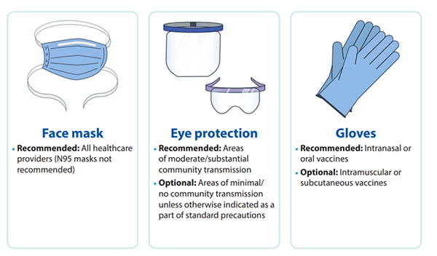

Dose Preparation:
- Store unpunctured multi-dose vials of the Janssen COVID-19 Vaccine at 36°F to 46°F and protect from light. Do not store frozen. Unpunctured vials of Janssen COVID-19 Vaccine may be stored between 47°F to 77°F for up to 12 hours.
- See EUA Fact Sheet for Providers for full process.
- The Janssen COVID-19 Vaccine is administered intramuscularly as a single dose (0.5 mL).
- The Janssen COVID-19 Vaccine is a colorless to slightly yellow, clear to very opalescent suspension. Visually inspect the vaccine vials for particulate matter and discoloration prior to administration. If either of these conditions exists, do not administer the vaccine.
- Before withdrawing each dose of vaccine, carefully mix the contents of the multi-dose vial by swirling gently in an upright position for 10 seconds. Do not shake.
- Each dose is 0.5 mL. Each vial contains five doses. Do not pool excess vaccine from multiple vials, and do not withdraw more than five doses. Either would be considered a medication error.
- The Janssen COVID-19 Vaccine does not contain a preservative. Record the date and time of first use on the Janssen COVID-19 Vaccine vial label. After the first dose has been withdrawn, hold the vial between 36° to 46°F for up to 6 hours or at room temperature (maximally 77°F) for up to 2 hours. Discard if vaccine is not used within these times.

Vaccine Administration
Visually inspect each dose in the dosing syringe prior to administration. The Janssen COVID-19 Vaccine is a colorless to slightly yellow, clear to very opalescent suspension. During the visual inspection,
- verify the final dosing volume of 0.5 mL.
- confirm there are no particulates and that no discoloration is observed.
- do not administer if vaccine is discolored or contains particulate matter.
Administer the Janssen COVID-19 Vaccine intramuscularly.

IM Injections in Deltoid Muscle
- Use proper landmarks and technique to identify the injection site.
- Use proper needle length for age and size of patient.
- Aspiration is not recommended when administering vaccines.
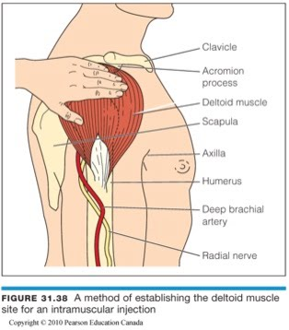

Information and Reporting Requirements
- The Janssen COVID-19 Vaccine is authorized for use in individuals 18 years of age and older.
- Provide “Fact Sheet for Recipients and Caregivers” prior to giving the Vaccine.
- Document in the state/local jurisdiction’s Immunization Information System (IIS) or other designated system. Advise recipient or caregiver that more information about IISs can be found at: https://www.cdc.gov/vaccines/programs/iis/about.html.
- The vaccination provider is responsible for mandatory reporting of the following to the Vaccine Adverse Event Reporting System (VAERS) vaccine administration errors whether or not associated with an adverse event, serious adverse events (irrespective of attribution to vaccination), cases of Multisystem Inflammatory Syndrome (MIS), and cases of COVID-19 that result in hospitalization or death.
- Submit reports to VAERS online at https://vaers.hhs.gov/reportevent.html.
- Provide the v-safe information sheet to vaccine recipients/caregivers and encourage vaccine recipients to participate in v-safe. V-safe is a new voluntary smartphone-based tool that uses text messaging and web surveys to check in with people who have been vaccinated to identify potential side effects after COVID-19 vaccination. V-safe asks questions that help CDC monitor the safety of COVID-19 vaccines. V-safe also provides second-dose reminders if needed and live telephone follow-up by CDC if participants report a significant health impact following COVID- 19 vaccination. For more information, visit: www.cdc.gov/vsafe.
- Provide a vaccination card to the recipient or their caregiver with the name of the vaccine (“Janssen COVID-19 Vaccine”) and date of administration to document vaccination.

Contraindications
Do not administer the Janssen COVID-19 Vaccine if the patient has a history of:
- Severe allergic reaction (e.g., anaphylaxis) to a component of Janssen COVID-19 Vaccine.
- Immediate allergic reaction of any severity or known (diagnosed) allergy to a component of the vaccine.
Note: Persons who have a contraindication to Janssen COVID-19 Vaccine may be able to receive an mRNA COVID-19 vaccine.

Warnings and Precautions
Appropriate medical treatment to manage immediate allergic reactions must be immediately available in the event an acute anaphylactic reaction occurs following administration of COVID-19 Vaccine.
Monitor Janssen COVID-19 vaccine recipients for the occurrence of immediate adverse reactions:
- 30 minutes: Persons with a history of:
  - an immediate allergic reaction of any severity to a vaccine or injectable therapy.
  - contraindications to other COVID-19 Vaccines who receive the Janssen COVID-19.
  - anaphylaxis due to any cause.
- 15 minutes: All other persons

Manage syncopal episodes with positioning and supportive care.

Adverse Reactions
- Adverse reactions reported in a clinical trial following administration of the Janssen COVID-19 Vaccine include injection site pain, headache, fatigue, myalgia, nausea, fever, injection site erythema and injection site swelling. In clinical studies, severe allergic reactions, including anaphylaxis, have been reported following the administration of the Janssen COVID-19 Vaccine (see Full EUA Prescribing Information).
- Additional adverse reactions, some of which may be serious, may become apparent with more widespread use of the Janssen COVID-19 Vaccine.
- Reports of adverse events following use of the Janssen COVID-19 Vaccine under emergency use authorization suggest an increased risk of thrombosis involving the cerebral venous sinuses and other sites (including but not limited to the large blood vessels of the abdomen and the veins of the lower extremities) combined with thrombocytopenia and with onset of symptoms approximately one to two weeks after vaccination. Most cases of thrombosis with thrombocytopenia reported following the Janssen COVID-19 Vaccine have occurred in females ages 18 through 49 years; some have been fatal (see Full EUA Prescribing Information).

