

**POSTPONED**

**Atrium Medical Center**

1 Medical Center Drive

Middletown, OH 45005

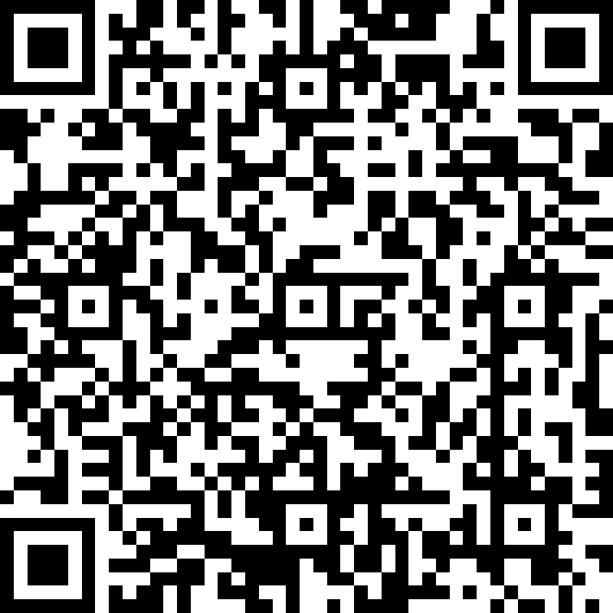

Premier Health

EMS Center of Excellence

Save the Date

**Paramedic Refresher (National Registry and State of Ohio hours)**

**Feb. 7th, 10th, 22nd, 25th March 3rd, 15th**

**9:00 a.m. – 5:30 p.m.**

Cost: $125.00

You will receive ITLS/ACLS/BLS

Location is Monroe Lending Library, 6 East Ave, Monroe, OH 45050

If further questions, contact:

Rich Morrett-EMS Coordinator, Atrium Medical Center

ramorrett@premierhealth.com



To register or for more information:

Accreditation site #332

Premier Health Emergency and Trauma Institute

P-C-EMS02882-2/20